Power BI Assignment 1 – Data Transformation & Data Modeling

NAME:Abinaya mondal DATE OF SUBMISSION:28/07/2026

ASSIGNMENT LINK:https://drive.google.com/file/d/1aCqSgiJou6MMQbPOebnQ3AX4SLbj5e-G/view?usp=sharing

Import Data:

Q1: Import “List of Orders.csv” into Power BI.

SCREENSHOT-1

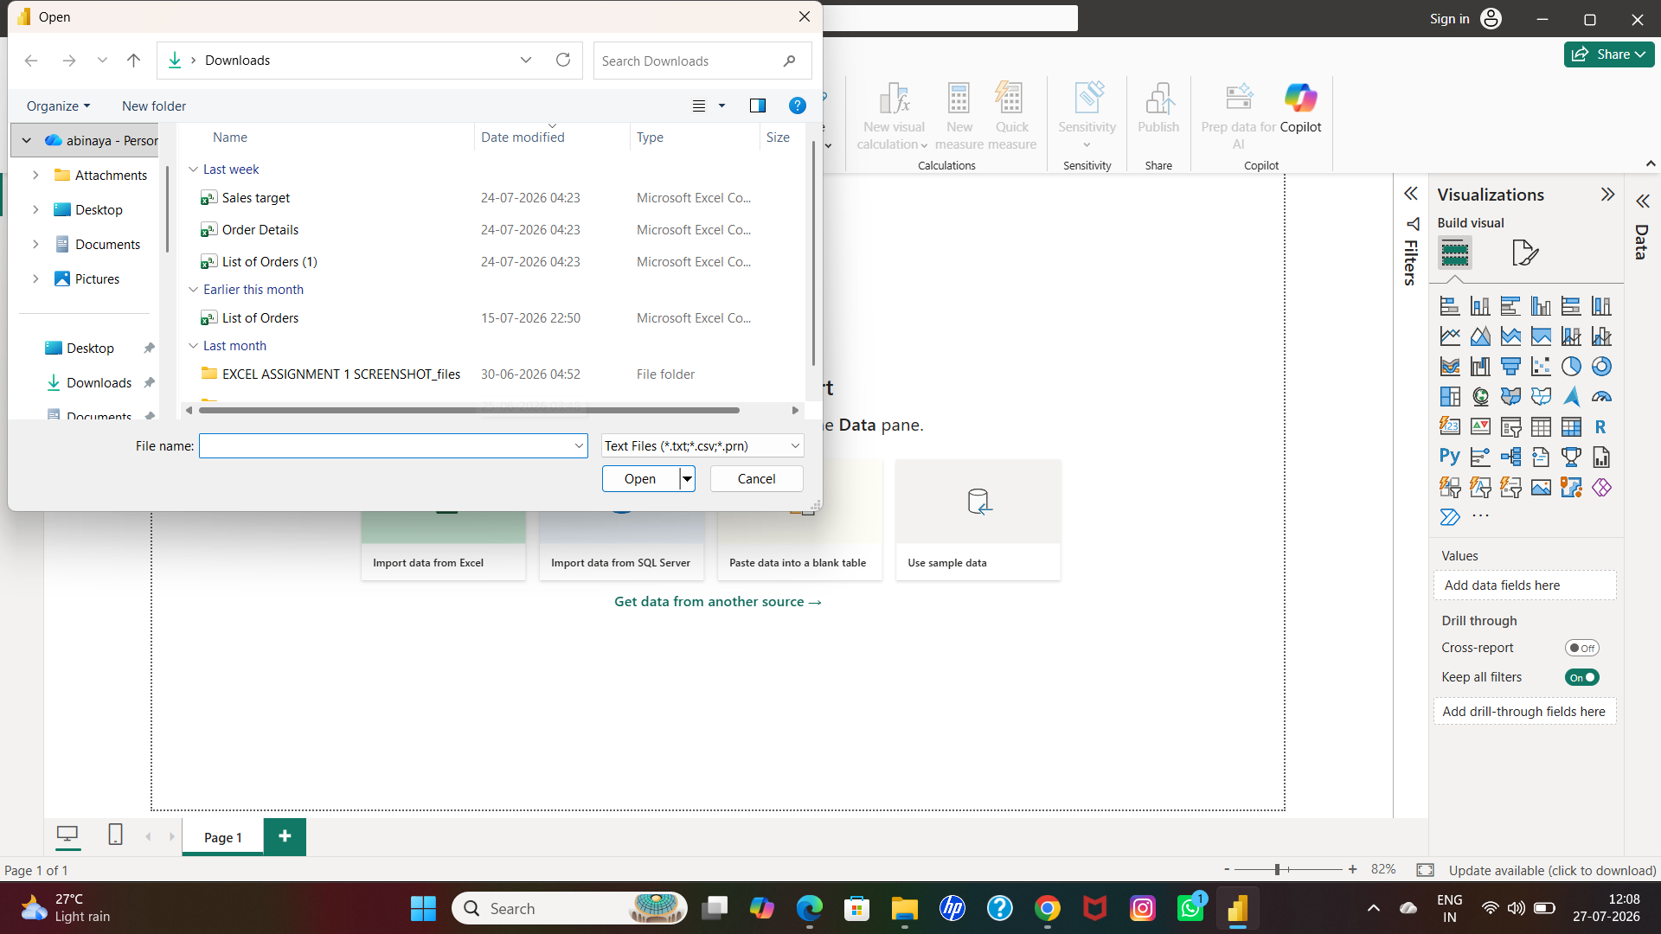

SOLUTION:

- Get data-open text /csv-list of orders-open

Q2: Open “List of Orders” in Power Query Editor by clicking on ‘Transform’.

SCREENSHOT-2

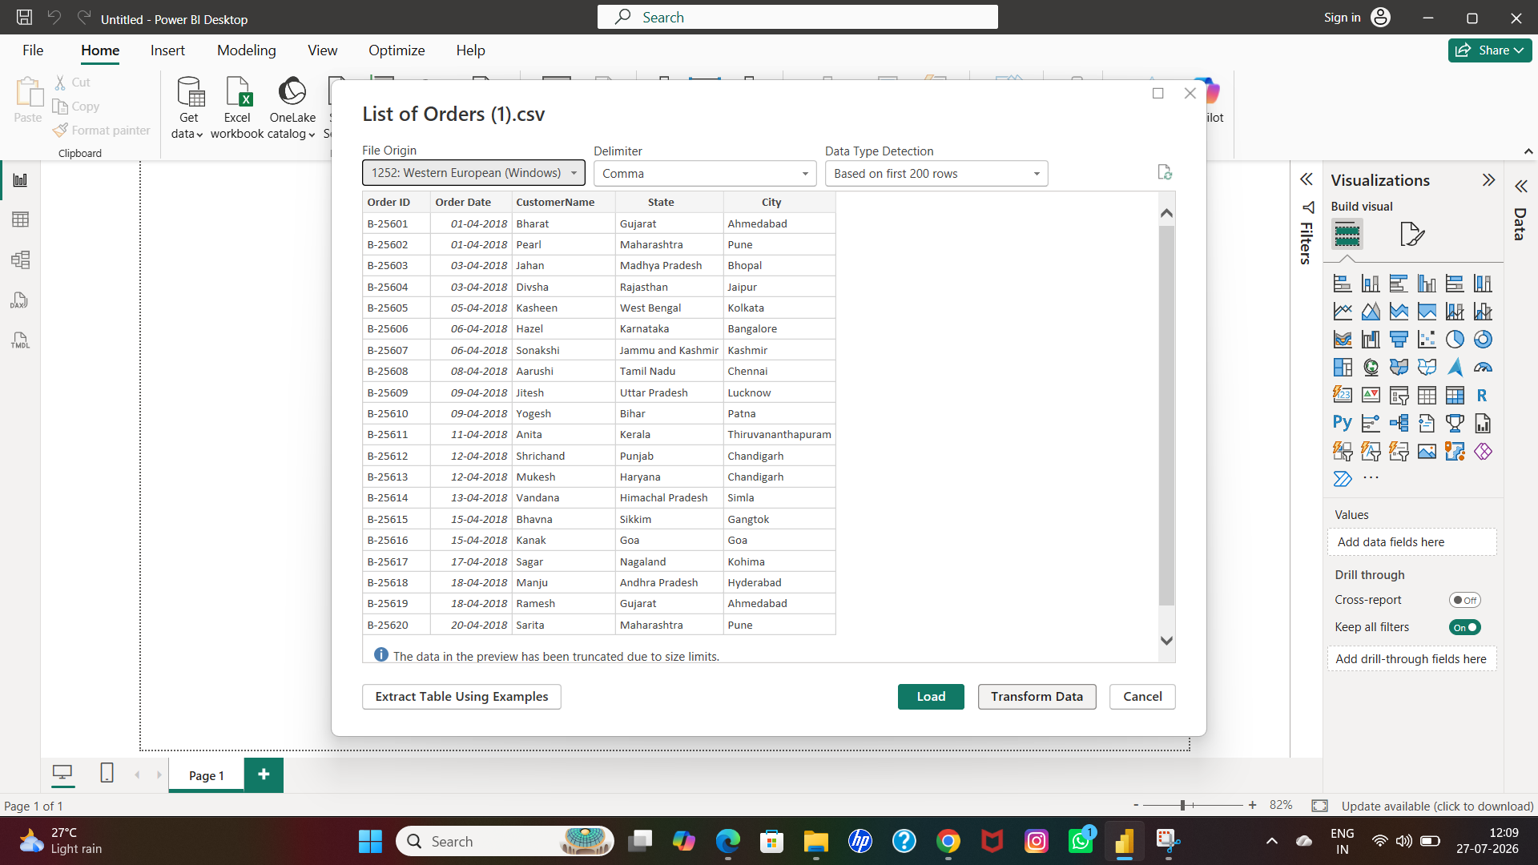

SOLUTION

- Get data-open text /csv-list of orders-open-tranform data

Q3: Import “Order Details.csv” and “Sales target.csv” into Power Query Editor.

SCREENSHOT-3

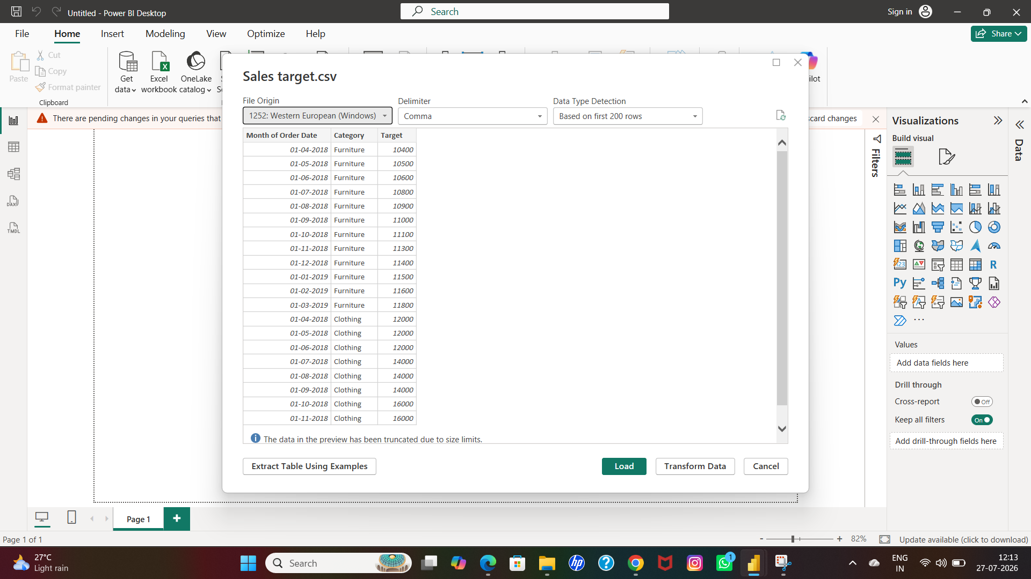

SOLUTION

- Get data-open text /csv-order details-open-transform data

SCREENSHOT-4

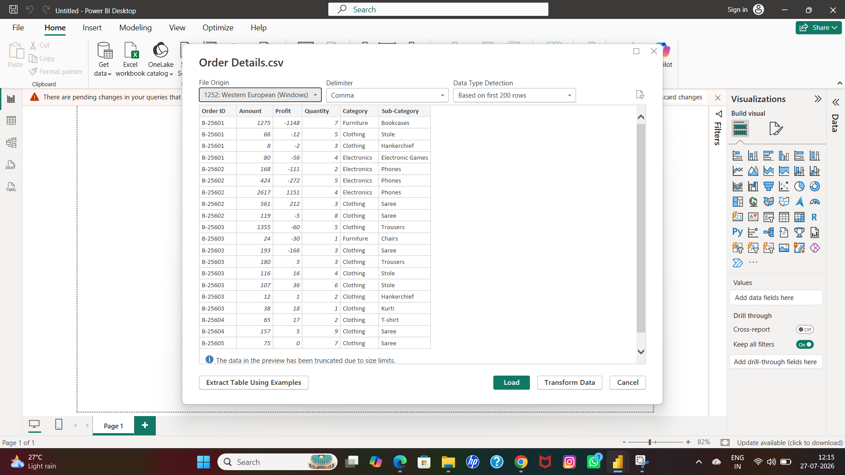

SOLUTION

- Get data-open text /csv-sales target-open-tranform data

Data Transformation:
Q4: Restrict the "List of Orders" table to only the first 500 rows.

SCREENSHOT-5

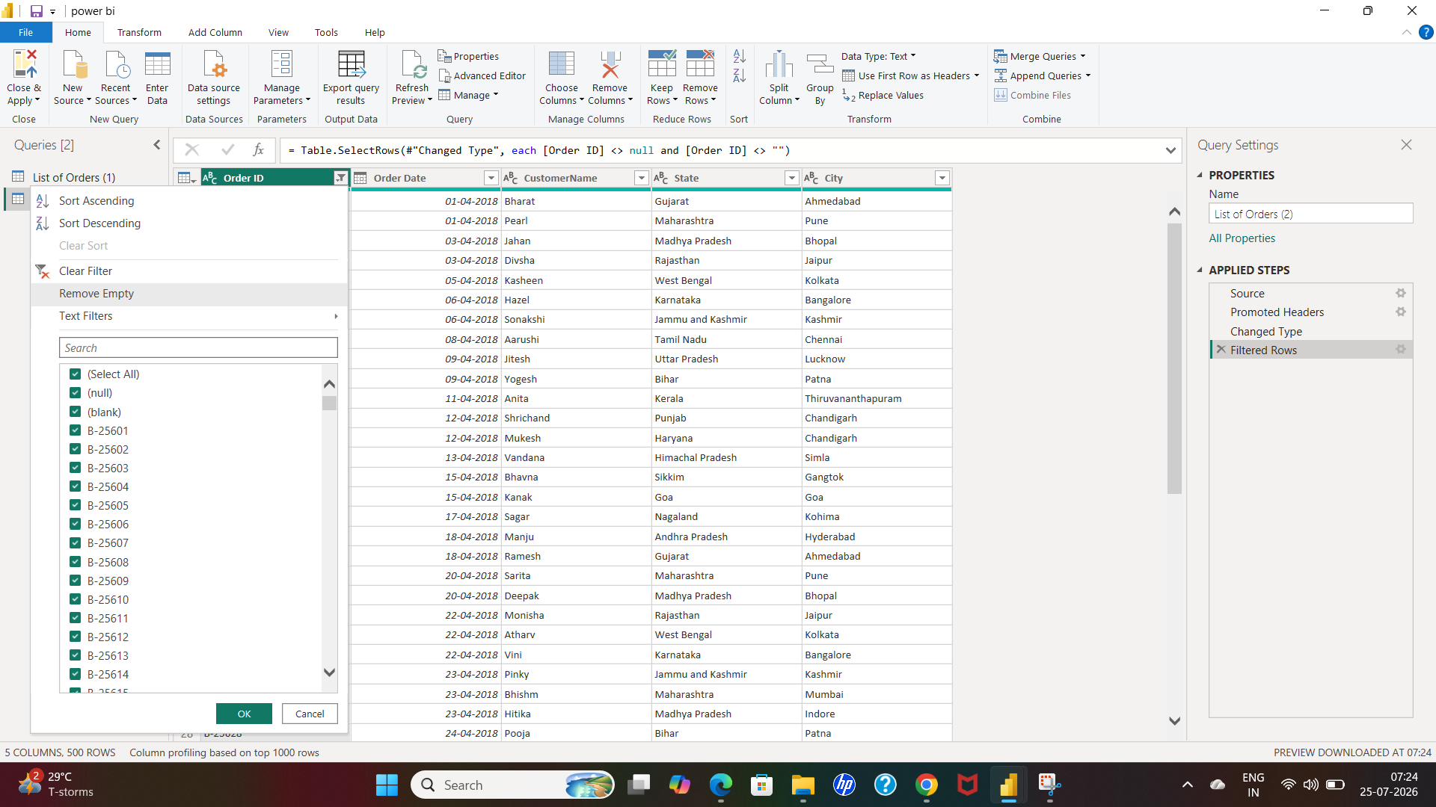

SOLUTION

- Click right side on the first column on the header

- Click remove empty option

Q5: Ensure the “Order Date” column in the “List of Orders” table is set to data type 'Date'.

SCREENSHOT-6

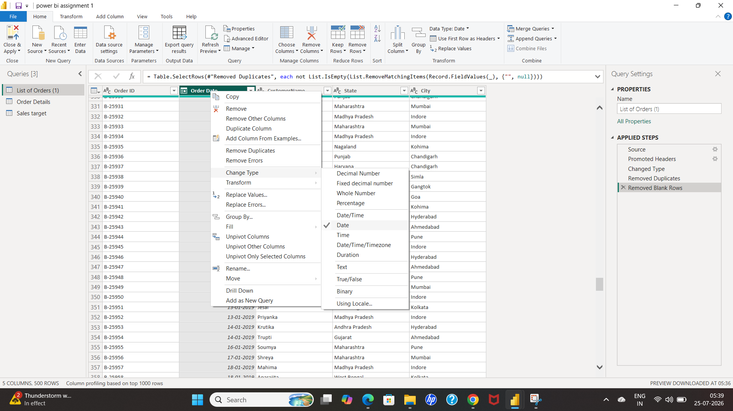

SOLUTION

- List of orders-order date-right click on the header

- choose change type-date

Q6: Change the data type of “Amount” and “Target” columns to ‘Fixed Decimal Number’.

SCREENSHOT-7

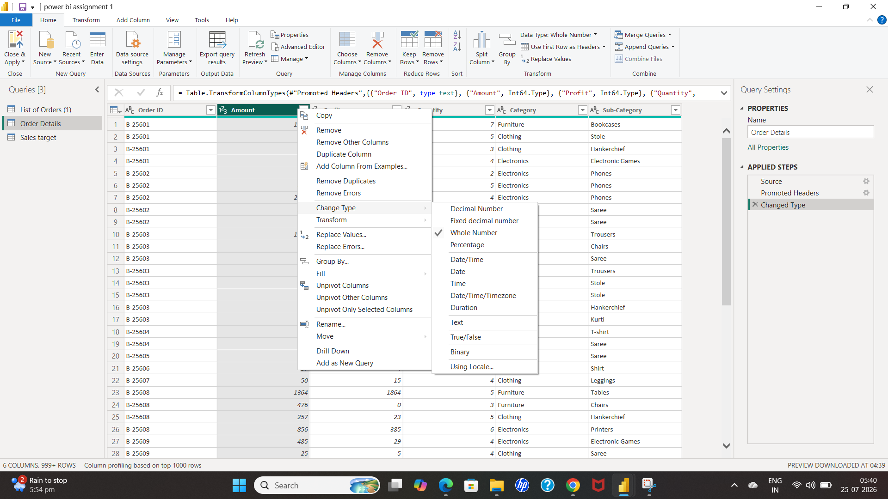

SOLUTION

- Orders details-amount-right click on the header

- choose change type-fixed Decimal number

SCREENSHOT-8

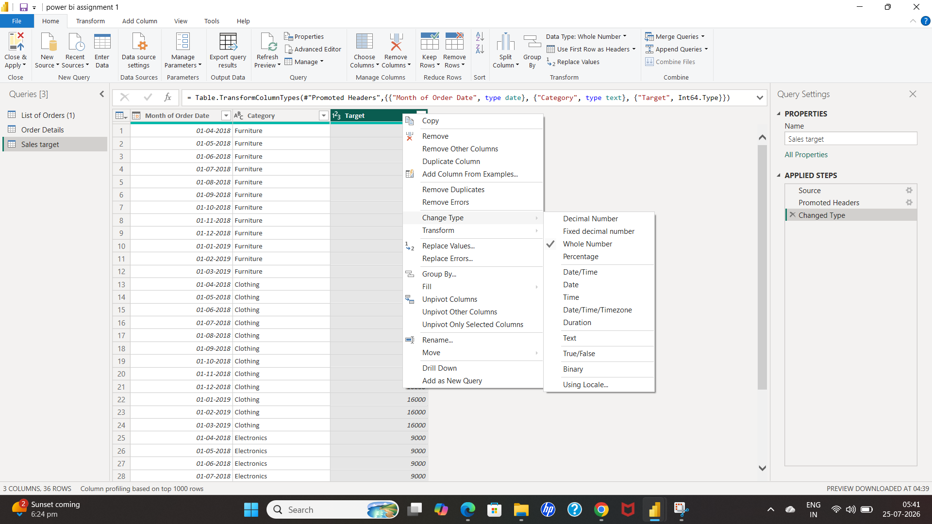

SOLUTION

- Sales target-target-right click on the column

- Choose change type-select fixed decimal number

Q7: Format the "CustomerName" column into proper case, ensuring consistent capitalization for each word.

SCREENSHOT-9

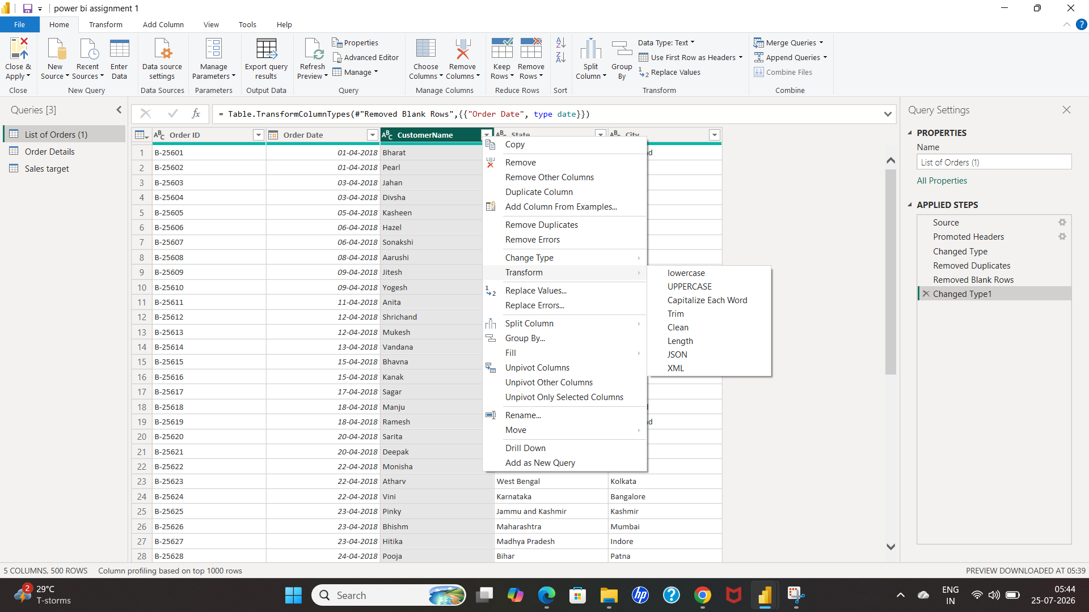

SOLUTION

- Select customer name column by click left click on the header

- Then right click on the header,choose transform-select capitalize each word

Q8: Merge the "State" and "City" columns to create a new column named "Location" in the format ‘City, State’.

SCREENSHOT-10

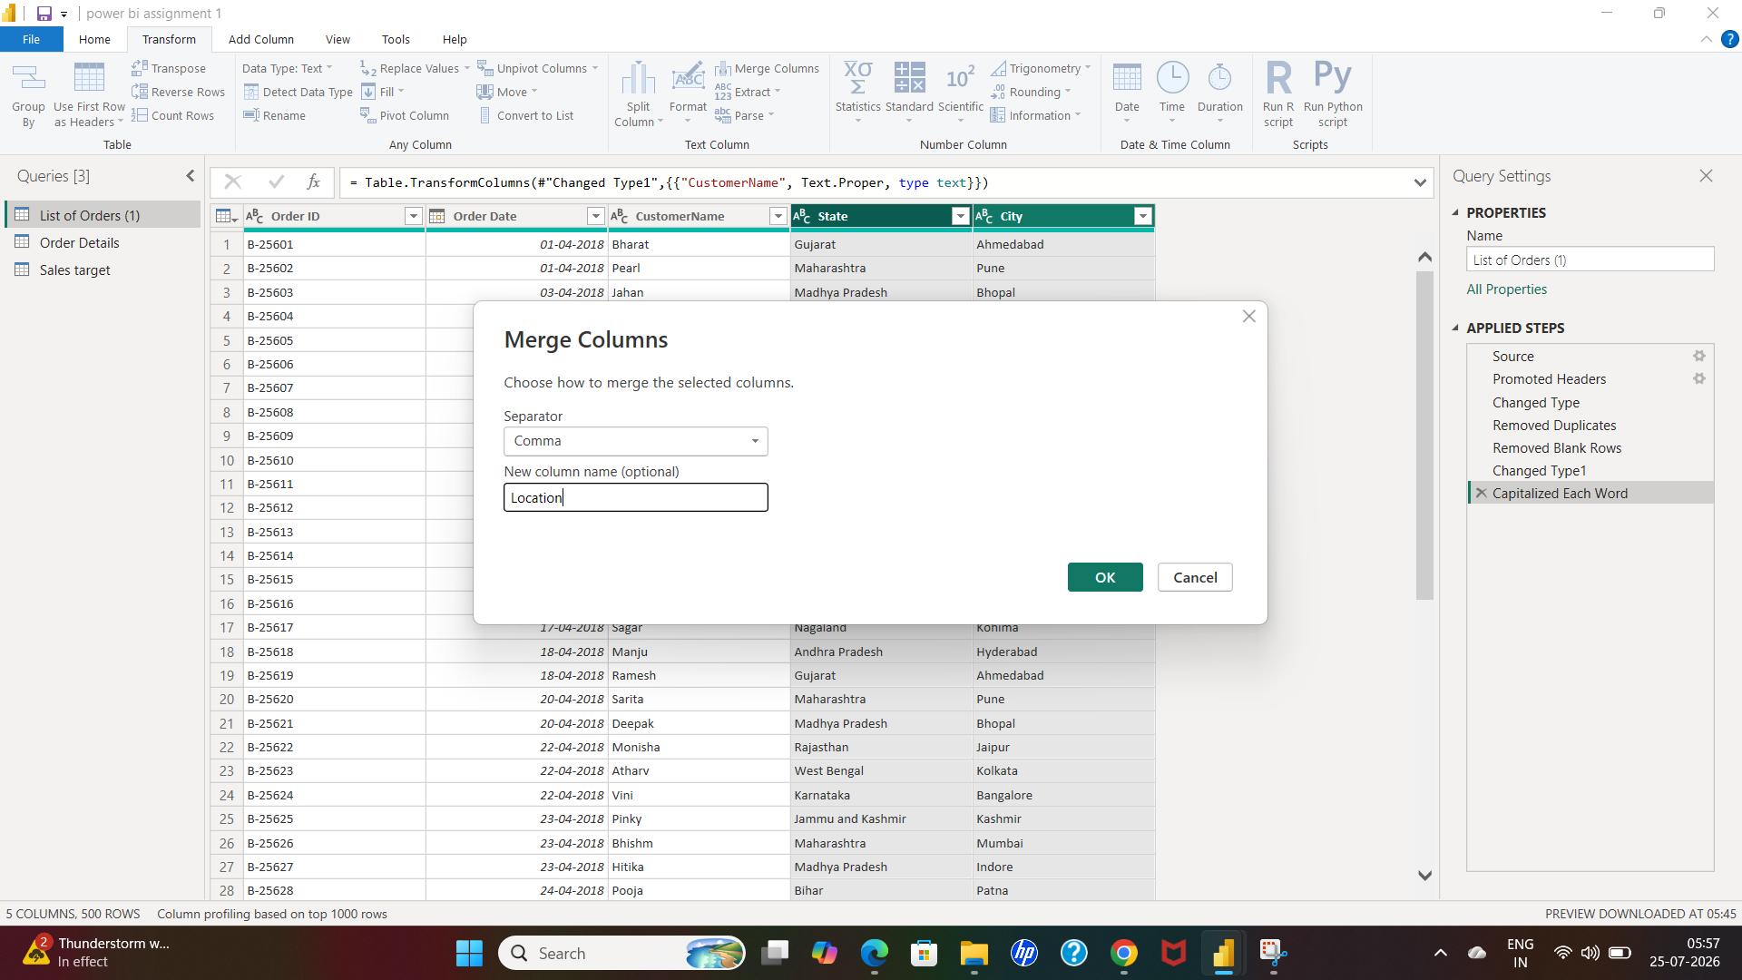

SOLUTION

- List of orders-select city and state column respectively by click shift+left click on mouse

- Then select add column -go with the merge column

- Then fill the box-in separator box-choose comma,

- Then new column name box-type Location
Then enter ok

SCREENSHOT-11

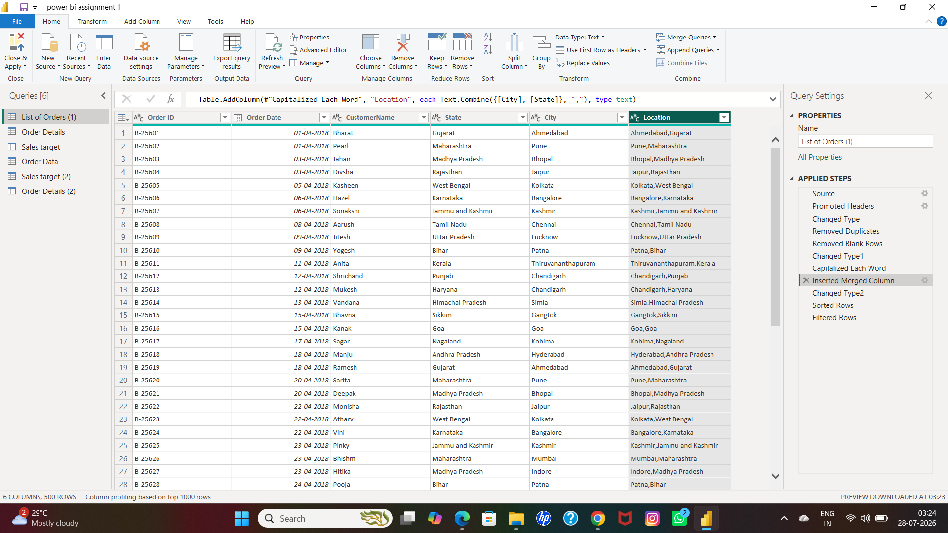

Q9: Create a new custom column named "Profit Margin" as the percentage of "Profit" divided by "Amount".

SCREENSHOT-12

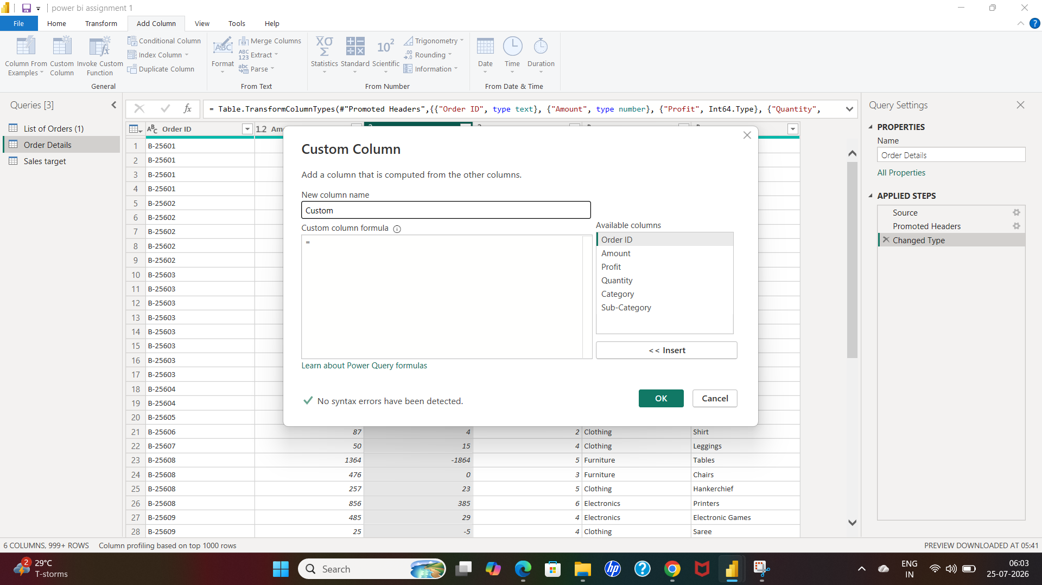

SCREENSHOT-13

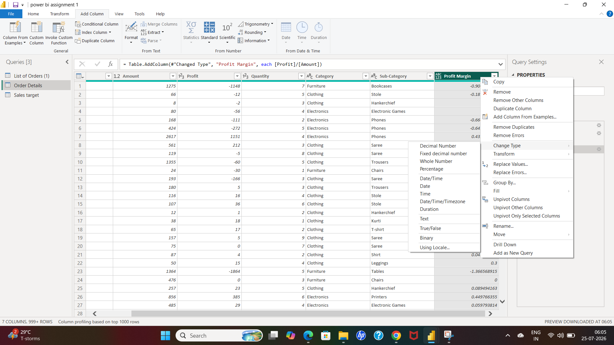

SOLUTION

- Order details-add column-select custom column-fill the box

- New column named “profit margin”

- Then select custom column formula”=profit/amount”

- Then right click on the header- select-change type and choose percentage

SCREENSHOT-14

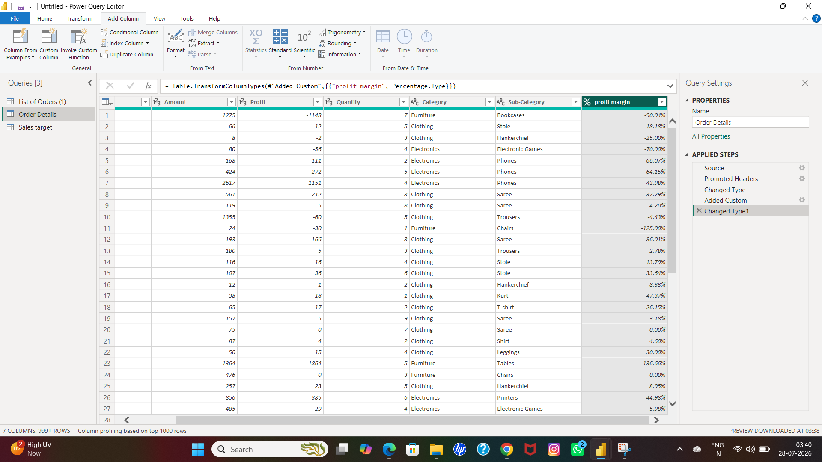

Q10: Add a new conditional column named "Profit Status" based on the values in the"Profit" column. The conditions are as follows: if the profit is less than 0, the label should be "Loss"; if the profit equals 0, the label should be "Break-Even"; and if the profit is greater than 0, the label should be "Profit".

SCREENSHOT-15

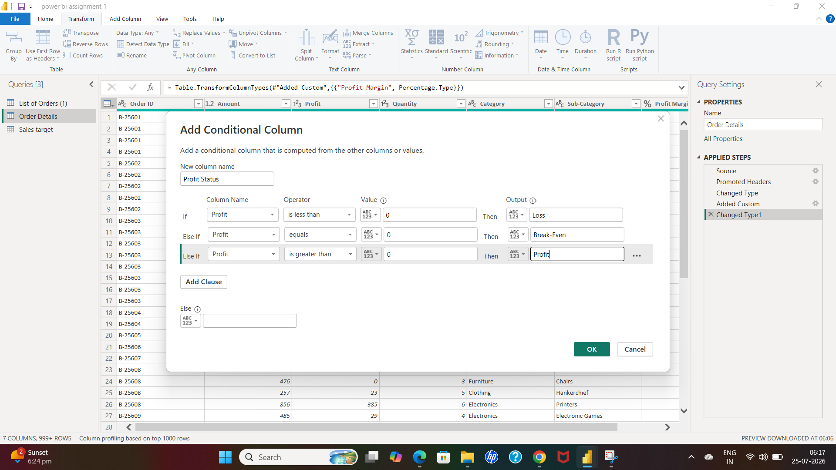

SOLUTION

- Order details-add column-select conditional column

- Fill up the box-new column named-Profit status

- Then apply the condition which is profit is “<0” label should be “loss”

- Then profit is “>0” the label should be “profit”

- Then profit is “=0” the label should be “break-even”

SCREENSHOT-16

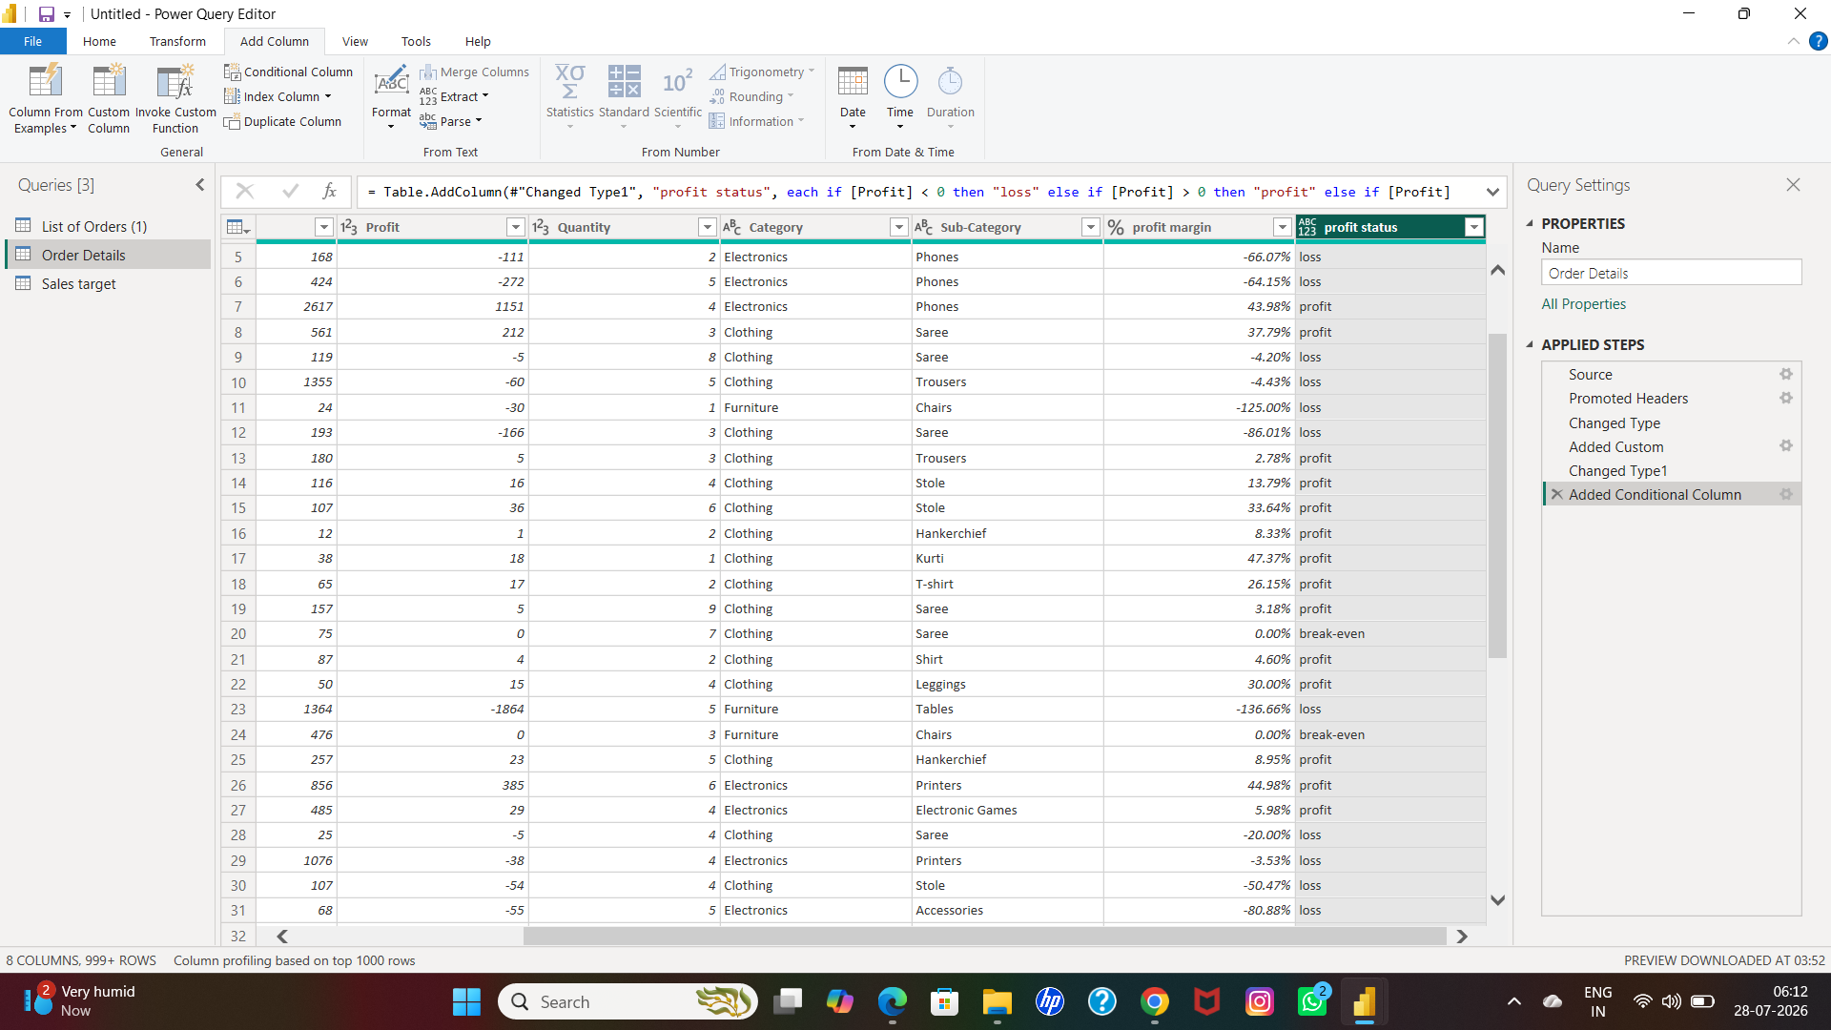

Q11: Merge the "List of Orders" and "Order Details" tables into a new single table named"Orders Data" based on the "Order ID" relationship.

SCREENSHOT-17

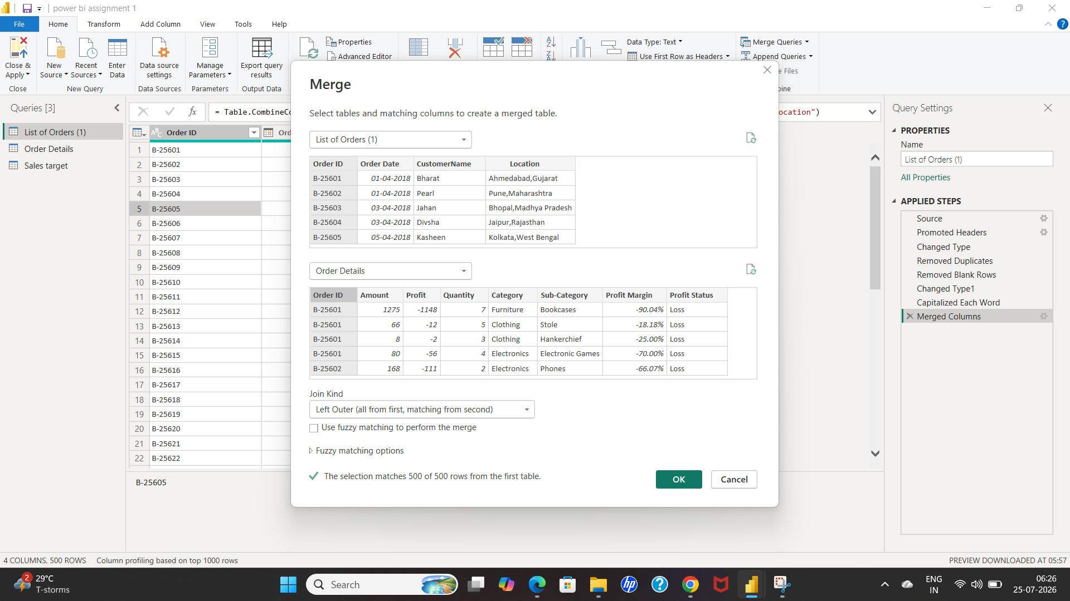

SOLUTION

- List of orders-file menu-go to merge queries as a new-fill up the box

- As per first box,choose list of orders and second box choose order details and select order id for both tables

- Enter ok and new table created then rename it by click right side on the header

- Then click left click on the header of the right side,a new box open for confirmation-click ok

SCREENSHOT-18

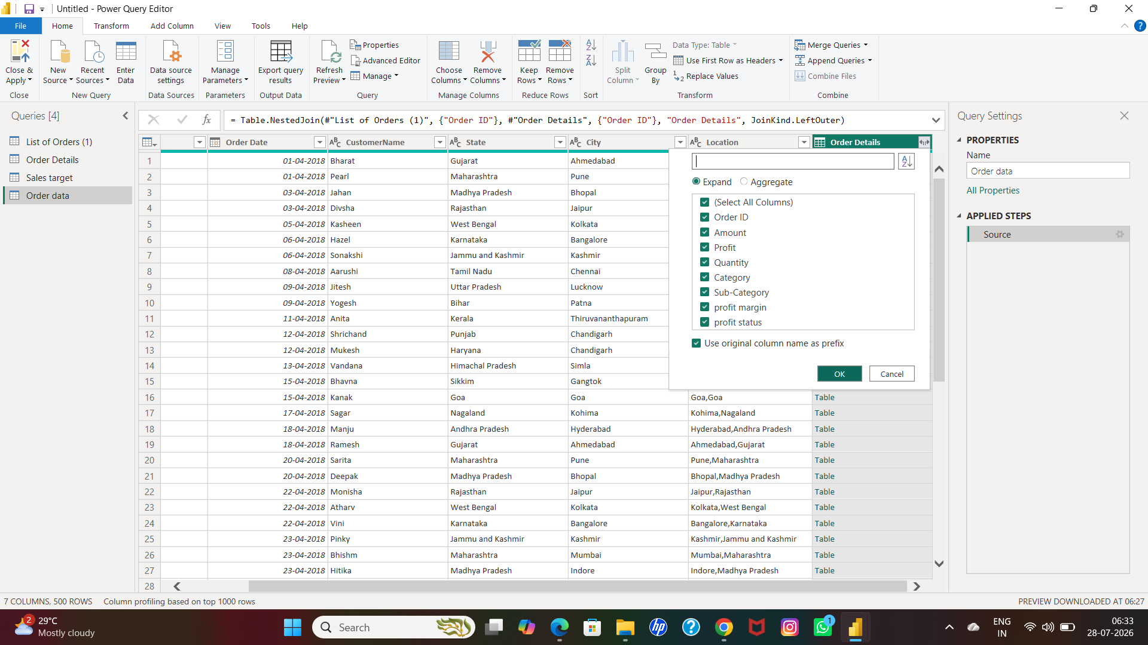

SCREENSHOT-19

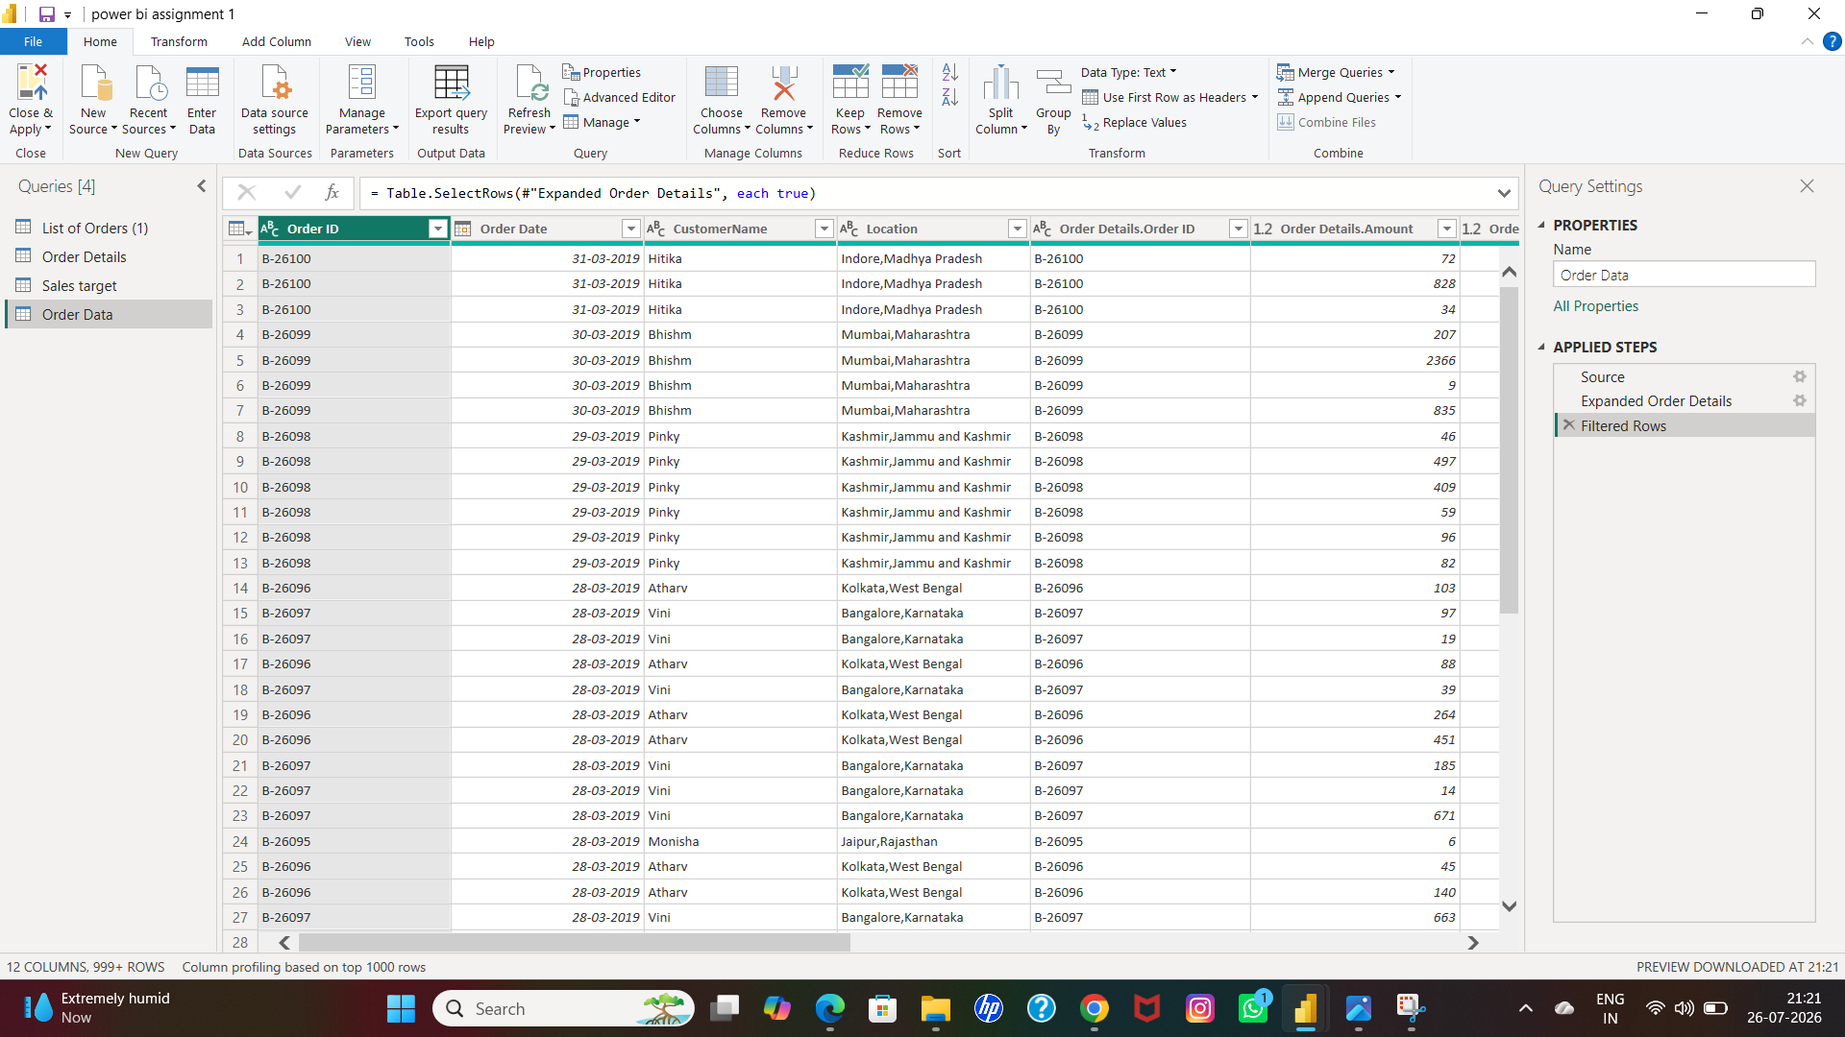

SCREENSHOT-20

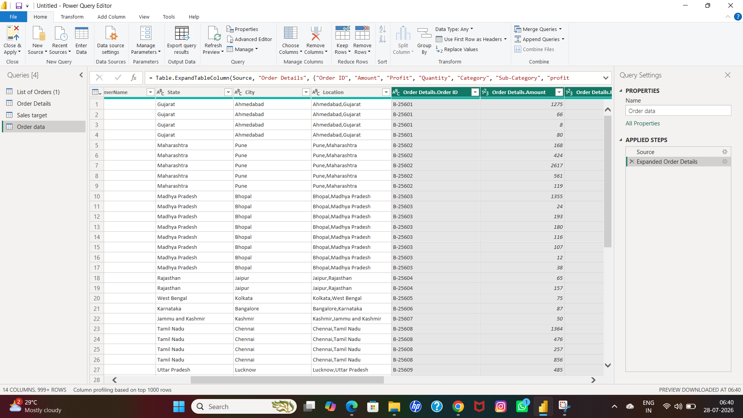

Q12: Identify missing values in the data and determine a strategy to address them.

SOLUTION

- There are no actual missing values in it.

- there are only null and empty rows which is actually got removed as per earlier cleaning steps

SCREENSHOT-21

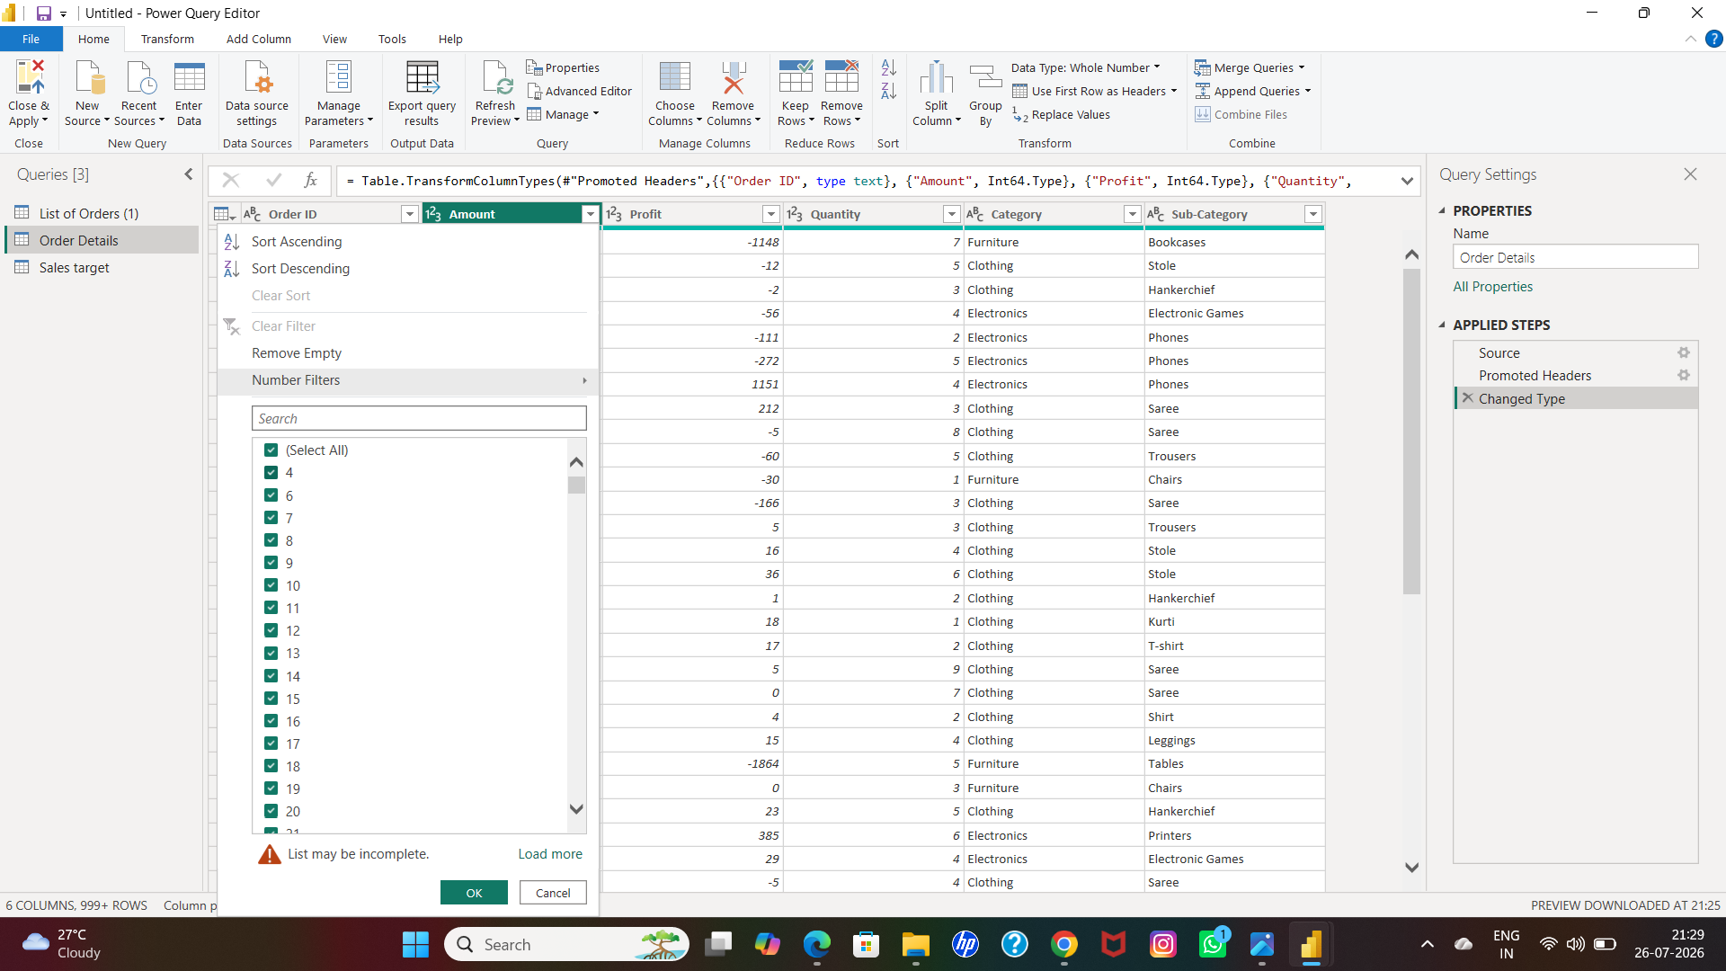

SCREENSHOT-22

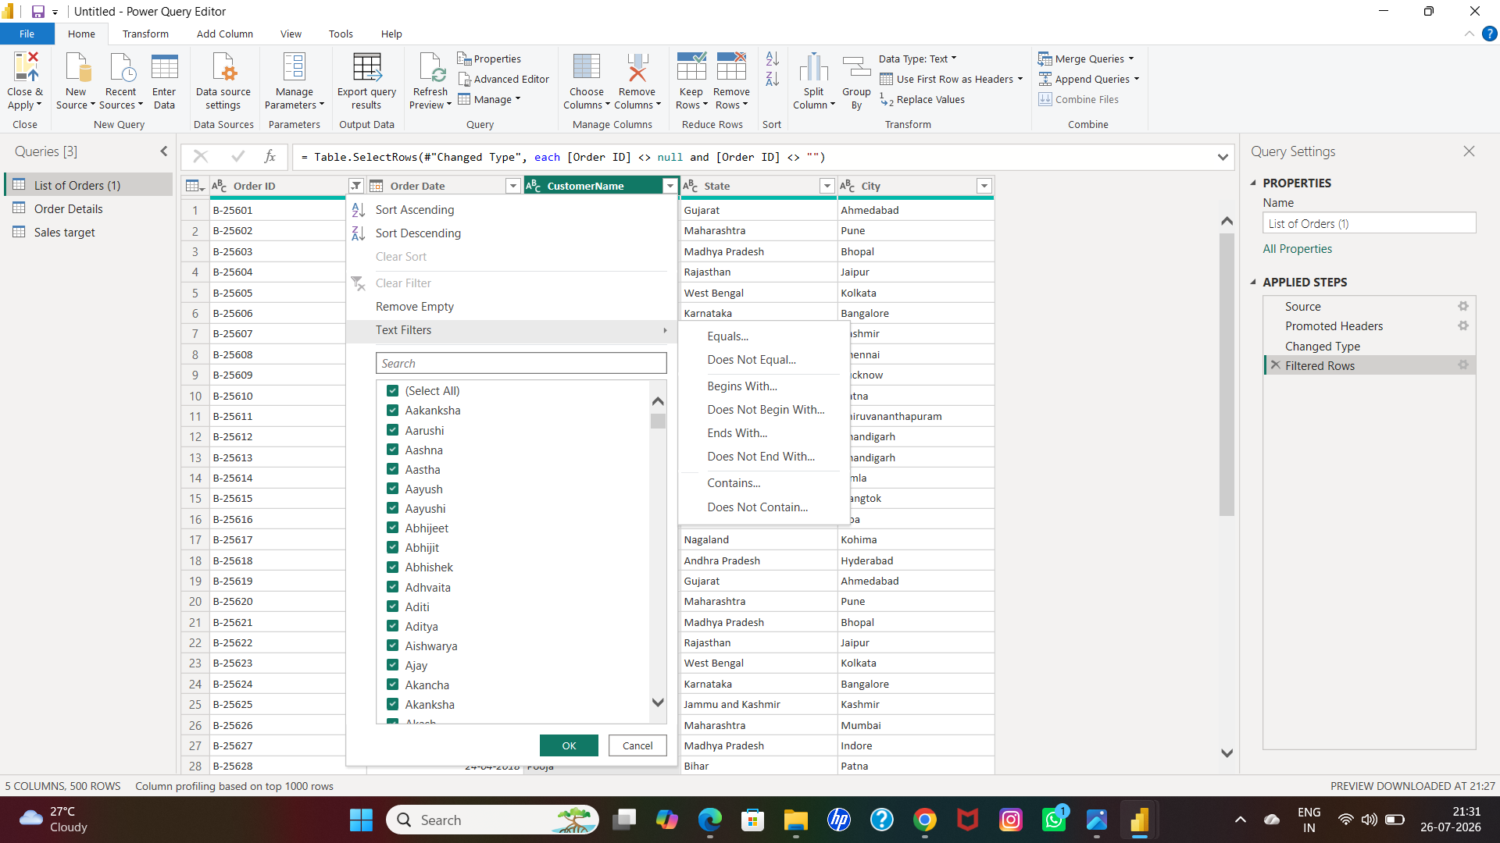

SCREENSHOT-23

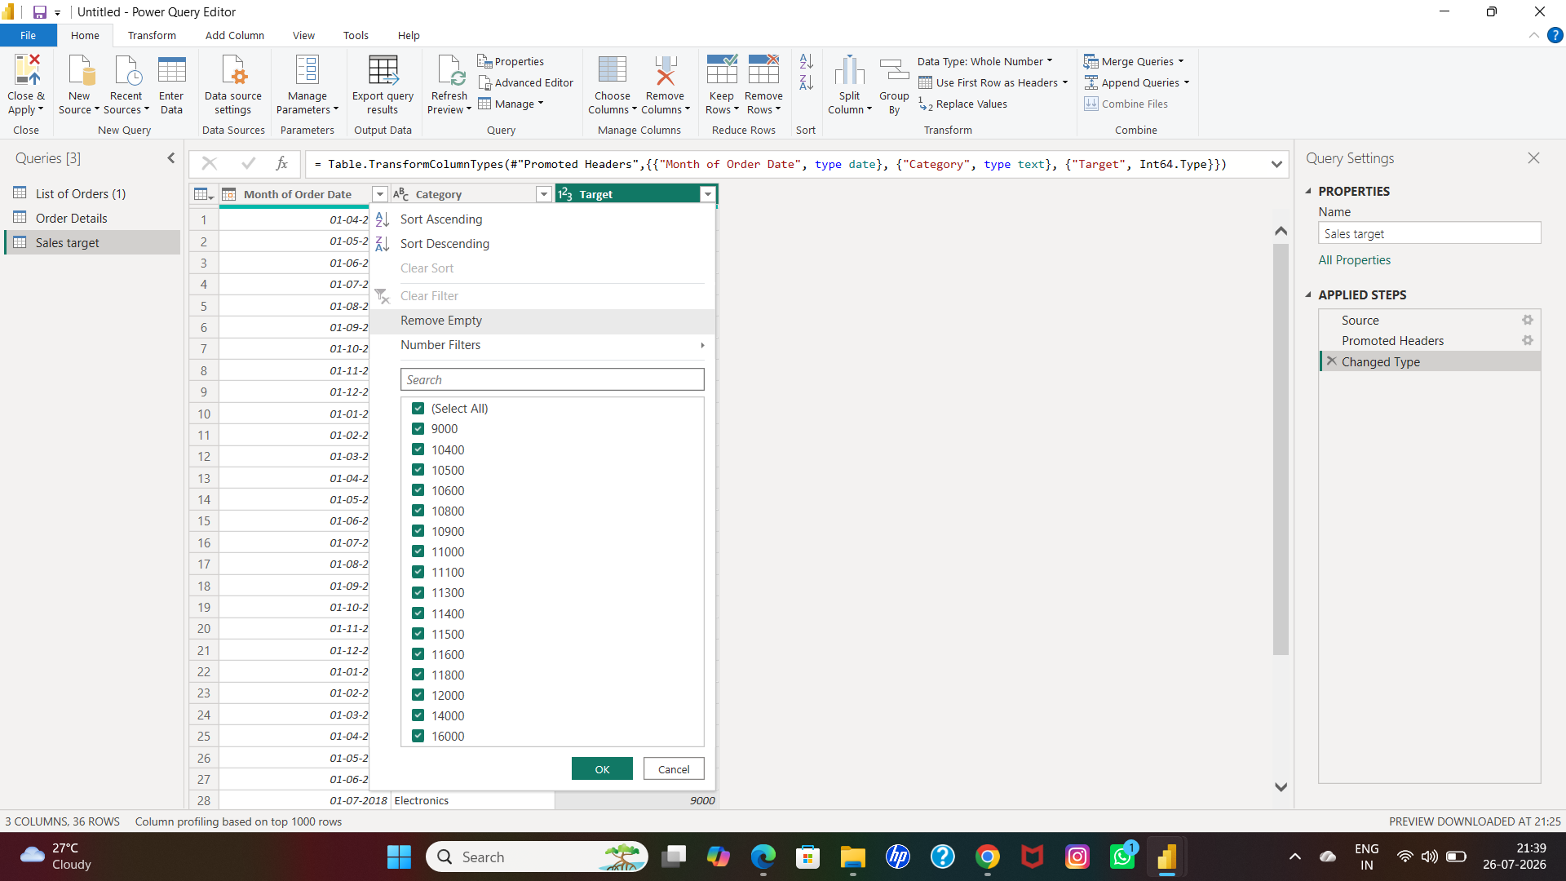

Q13: Check for duplicate rows and define a strategy to handle duplicates.

SOLUTION

- Go to list of orders-select first column by click left click -click left side of the header-chose kept duplicates.

- There are no duplicates in it

SCREENSHOT-24

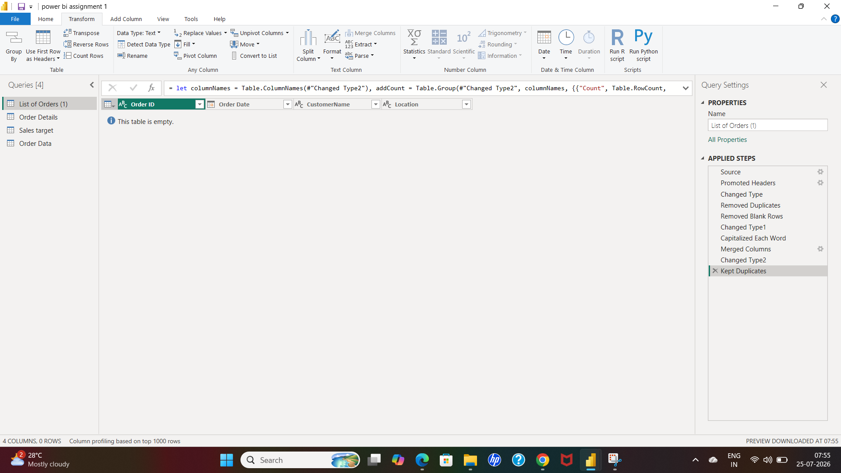

SOLUTION

- Go to order details-select first column by click left click -click left side of the header-choose kept duplicates.

- There are no duplicates in it

SCREENSHOT-25

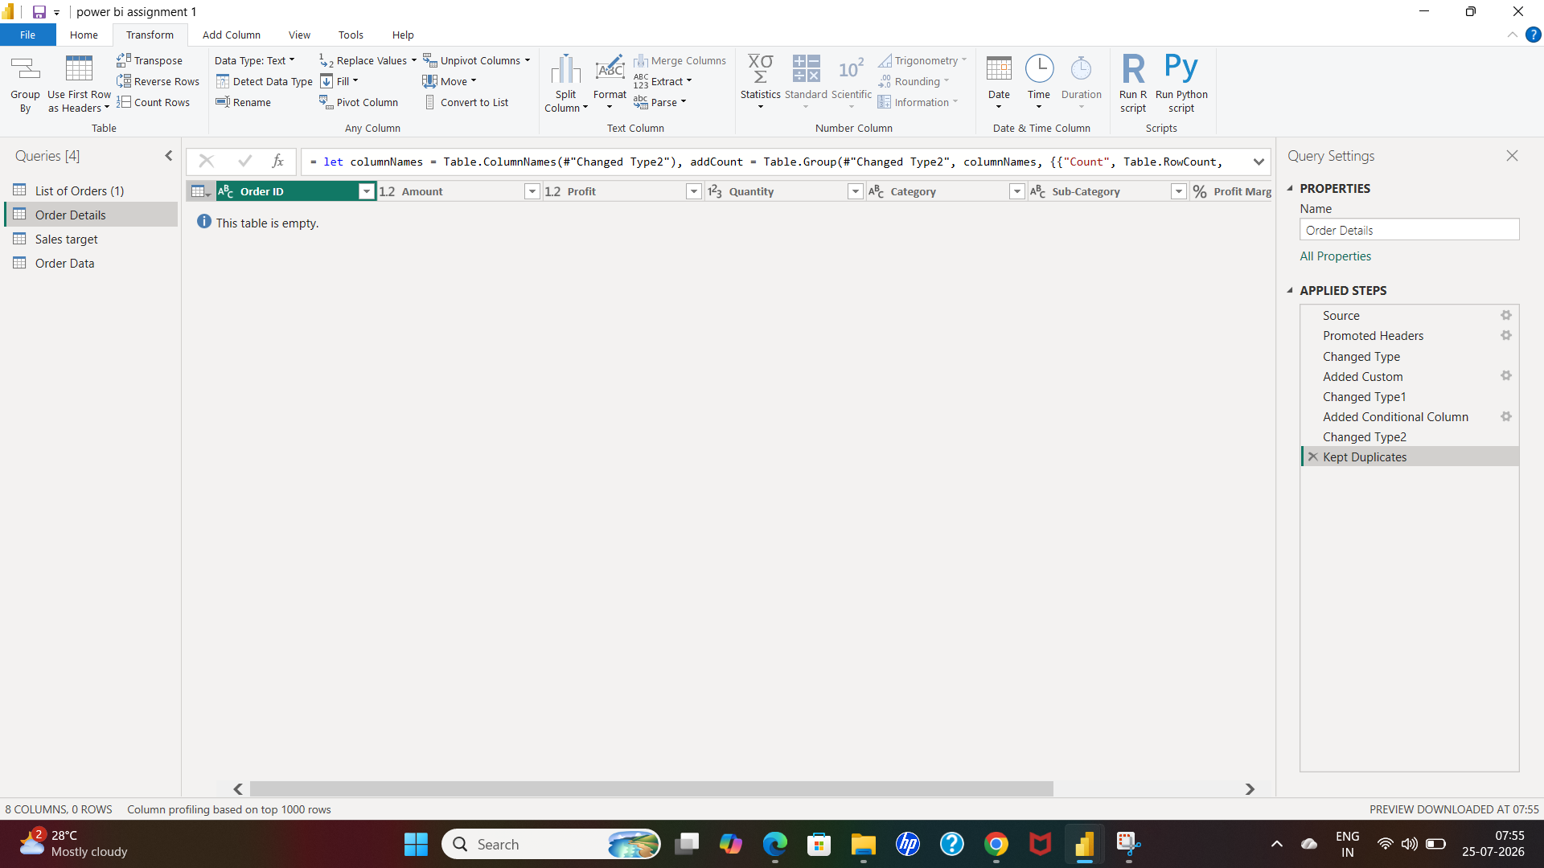

SOLUTION

- Go to order details-select first column by click left click -click left side of the header-choose kept duplicates.

- There are no duplicates in it

SCREENSHOT-26

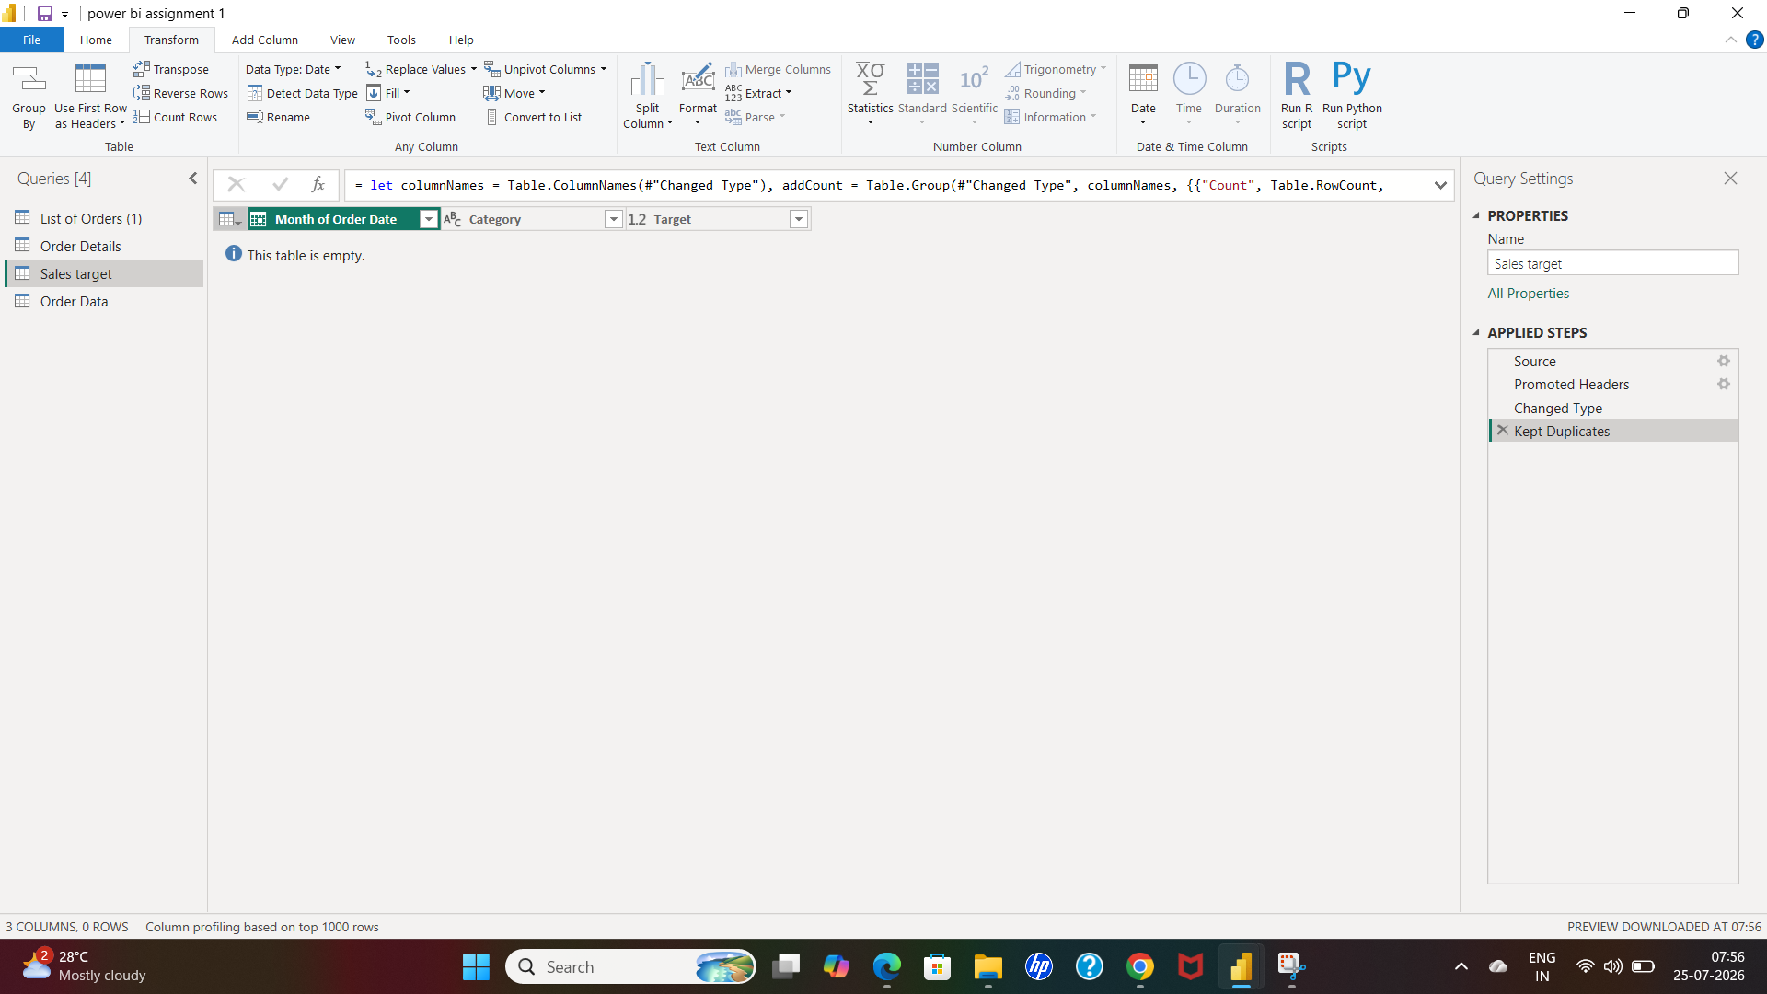

Q14: In the ‘Orders Data’ table, utilize sorting and filtering techniques on columns like Order Date, State or Category to analyze data based on specific criteria:

SCREENSHOT-27

ORDER DATE WISE

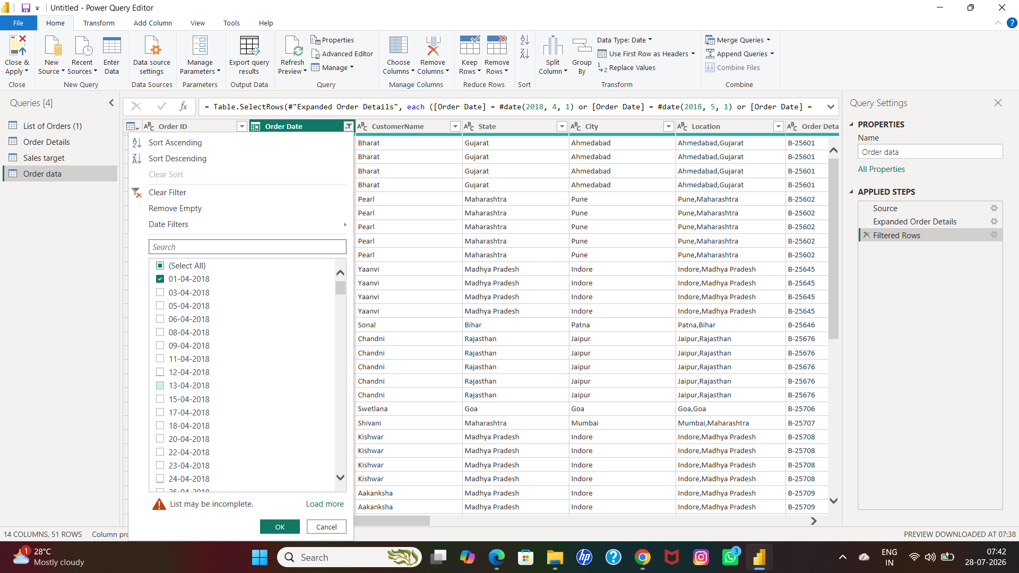

SCREENSHOT-28

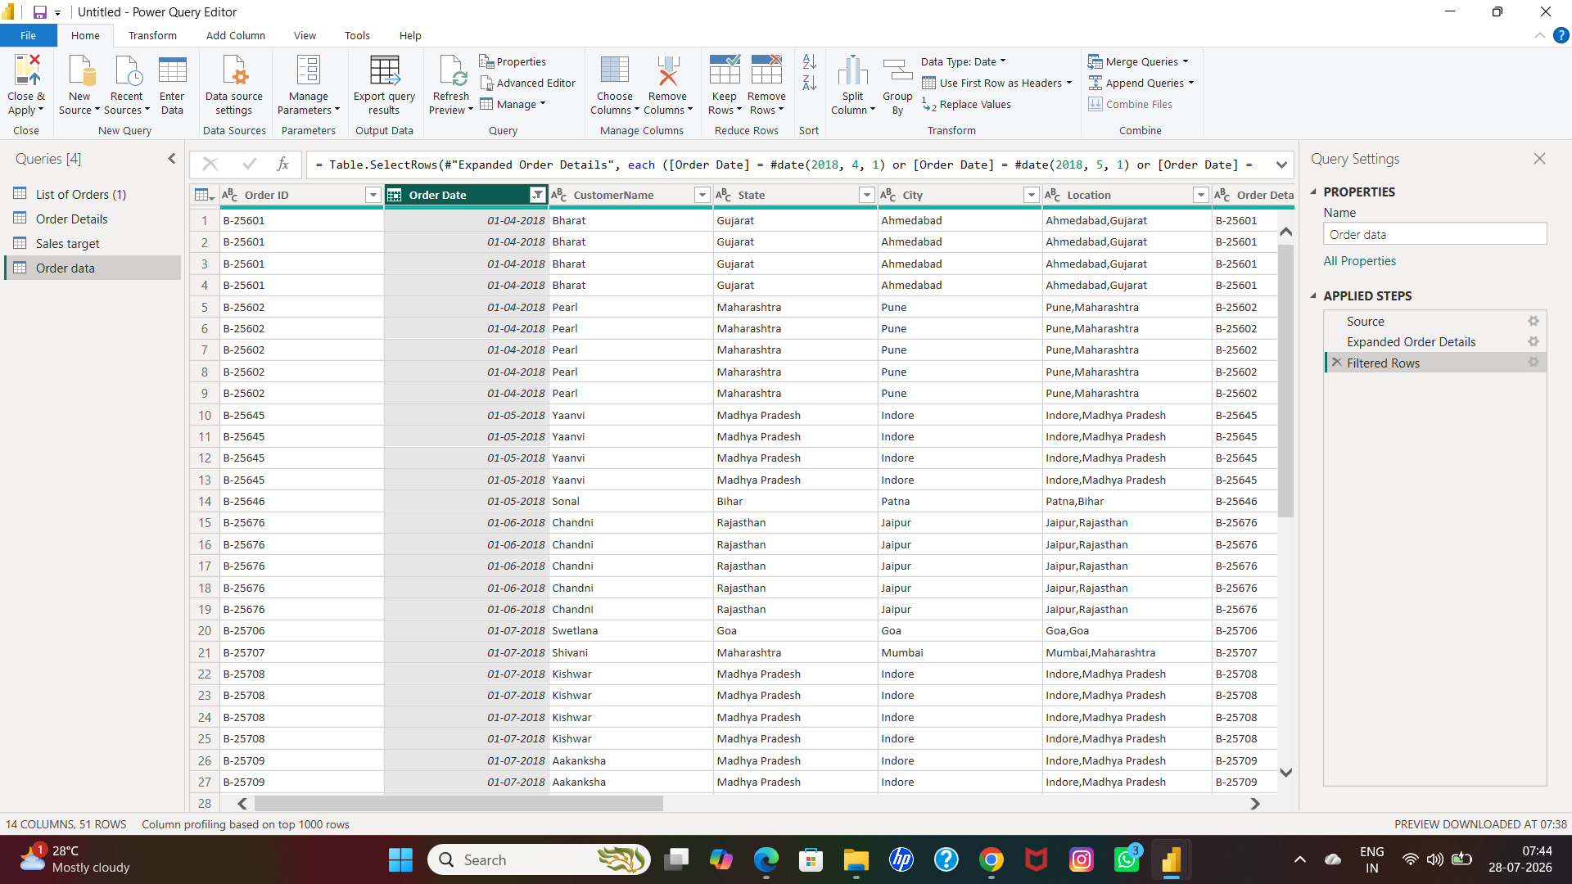

SOLUTION

- Order data-order date-left click on the header

- And i had chose specifically 1st of every month on filter column by clicking left click on the right of the header

- And click ok

SCREENSHOT-28

STATE WISE

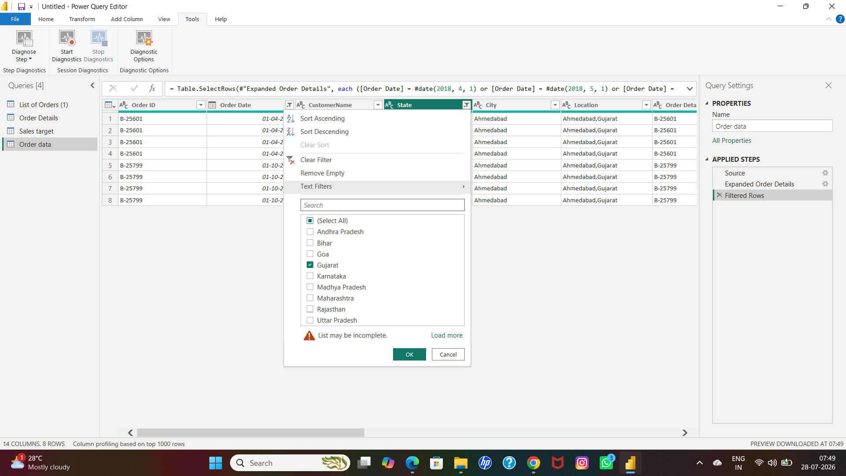

SCREENSHOT-29

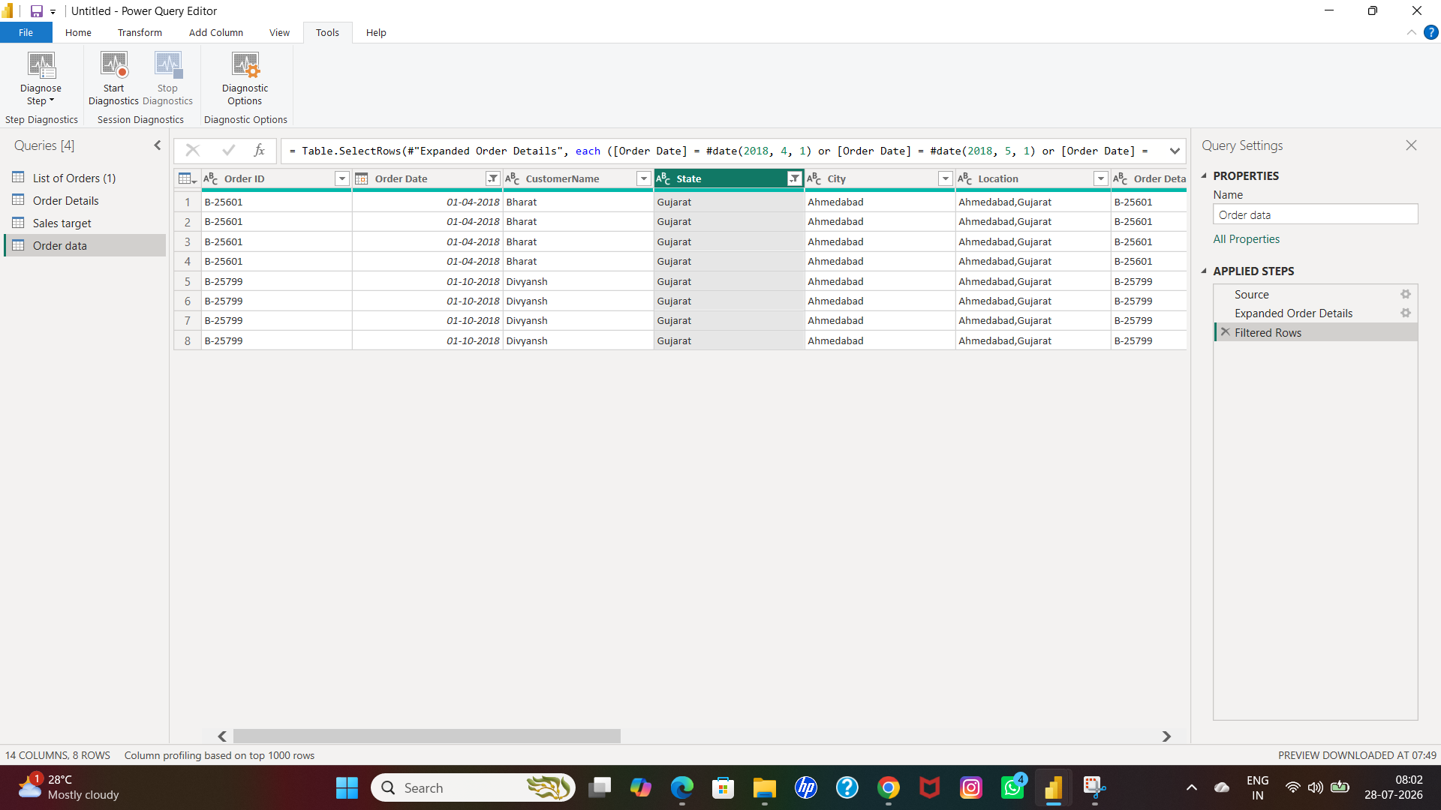

SOLUTION

- Order data-state-left click on the header

- And i had chose specifically gujarat on filter column by clicking left click on the right of the header

- And click ok

SCREENSHOT-30

CATEGORY WISE

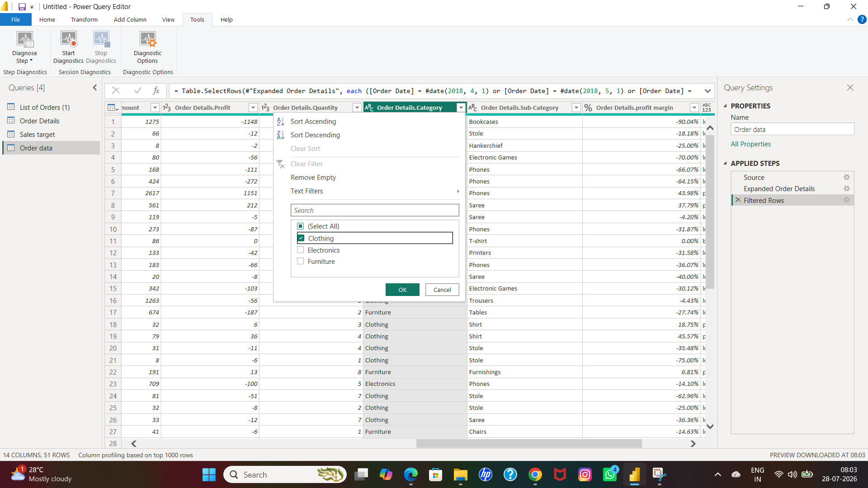

SCREENSHOT-31

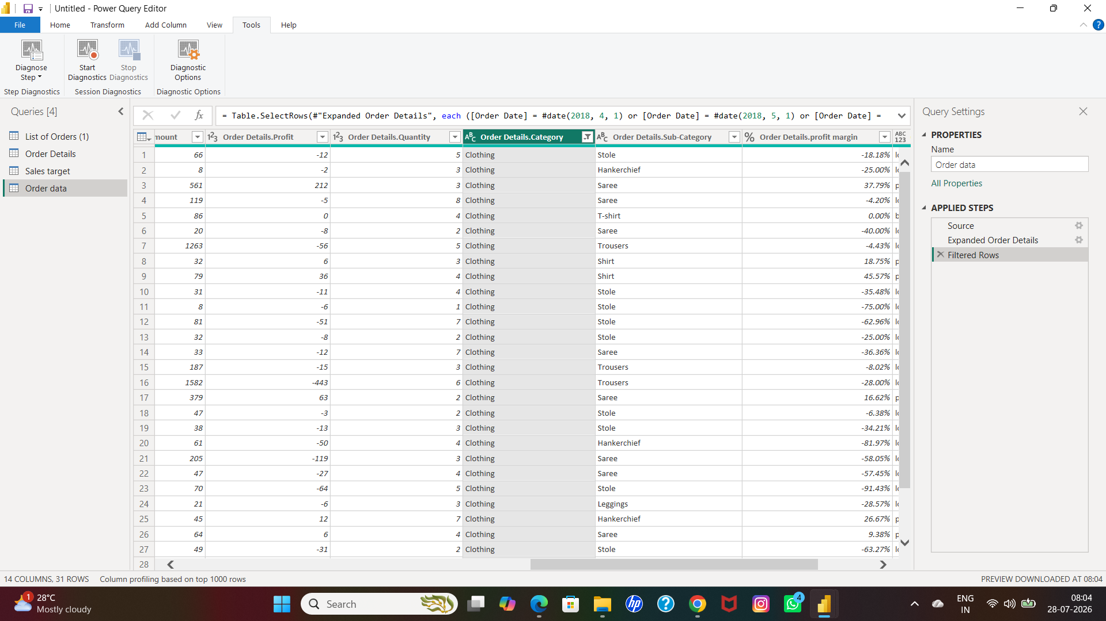

SOLUTION

- Order data-category-left click on the header

- And i had chose specifically clothing on filter column by clicking left click on the rIght of the header

- And click ok

Q15: Sort the orders by Order Date in descending order to analyze recent trends.

SCREENSHOT-32

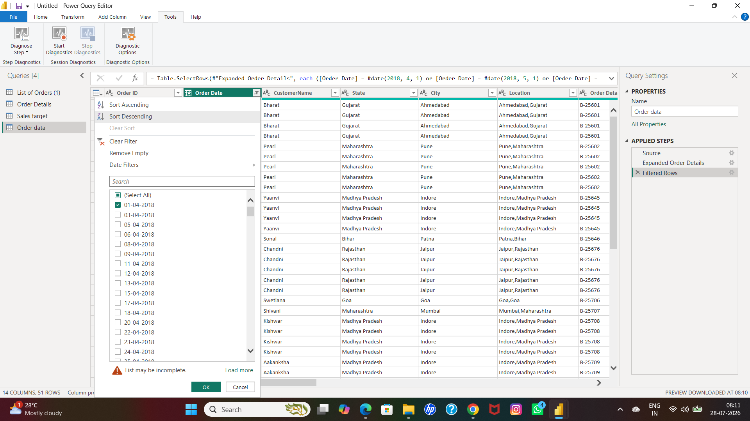

SCREENSHOT-33

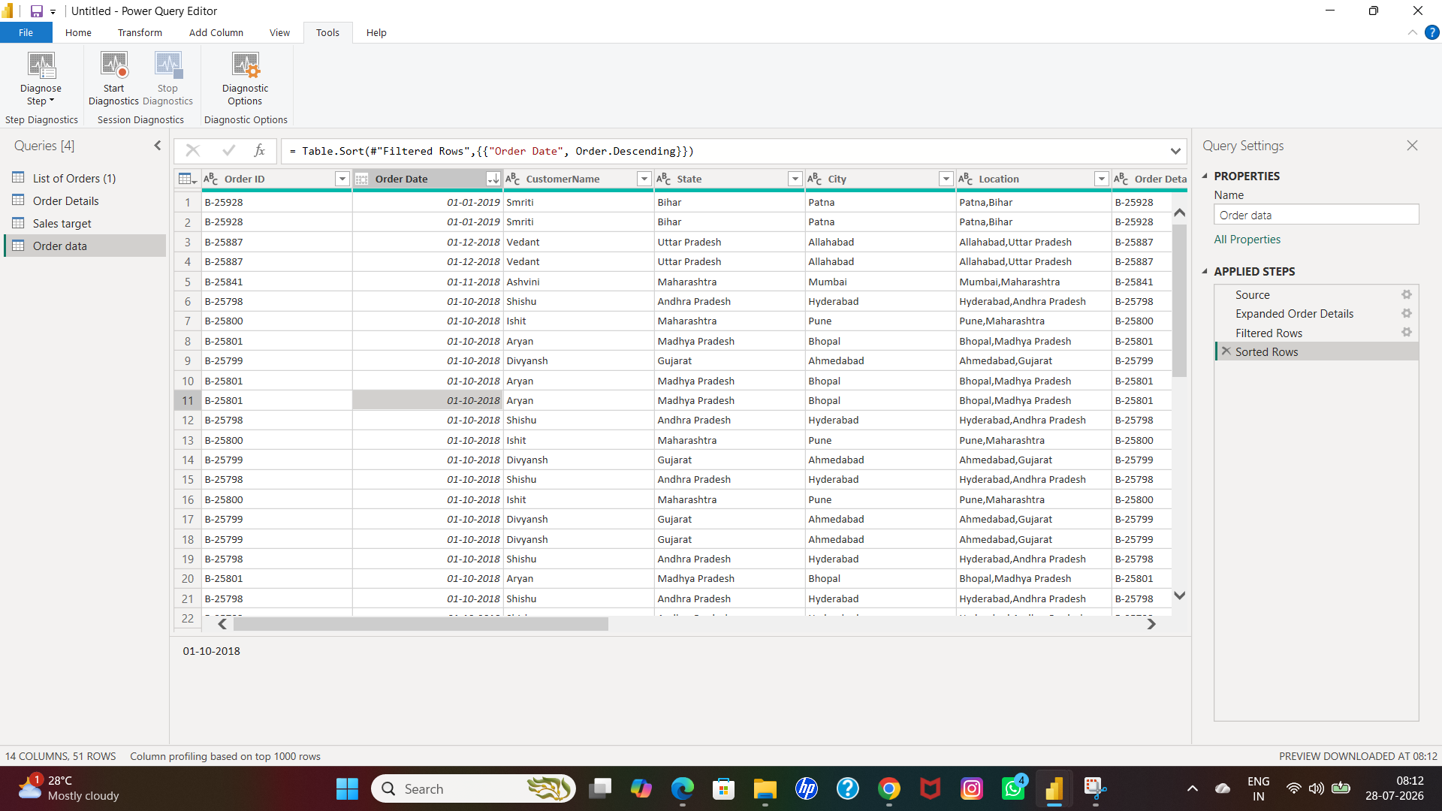

SOLUTION

- Order data-order date-select the column by clicking left click on the header

- And choose sort descending order click ok

Q16: Filter the orders to focus only on a specific state (e.g., Tamil Nadu) regional analysis.

SCREENSHOT-34

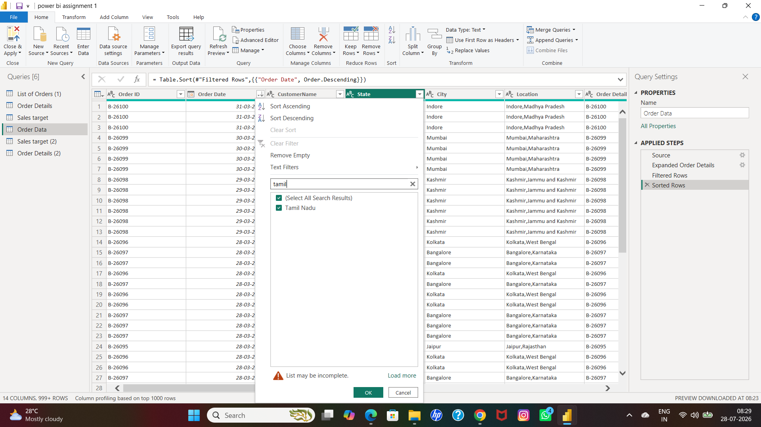

SCREENSHOT-35

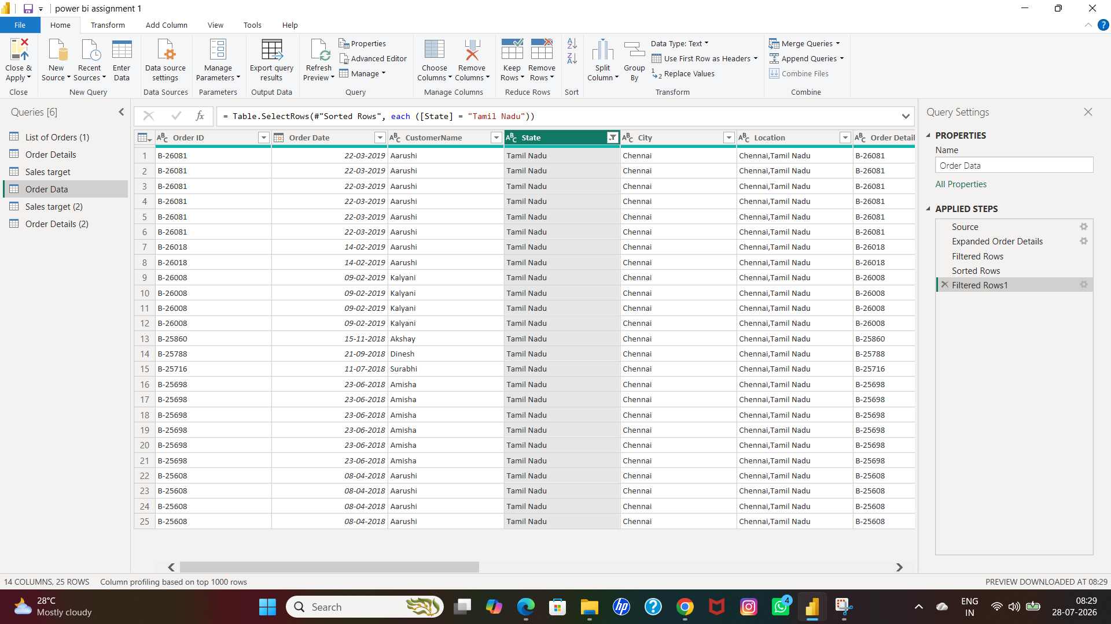

SOLUTION

- Order data-state-left click on the right of the header

- Open box-choose tamilnadu click ok

Q17: Duplicate the “Order Details” table and calculate the count of each Order ID, average profit by Category or total amount by Sub-Category.

SCREENSHOT-36

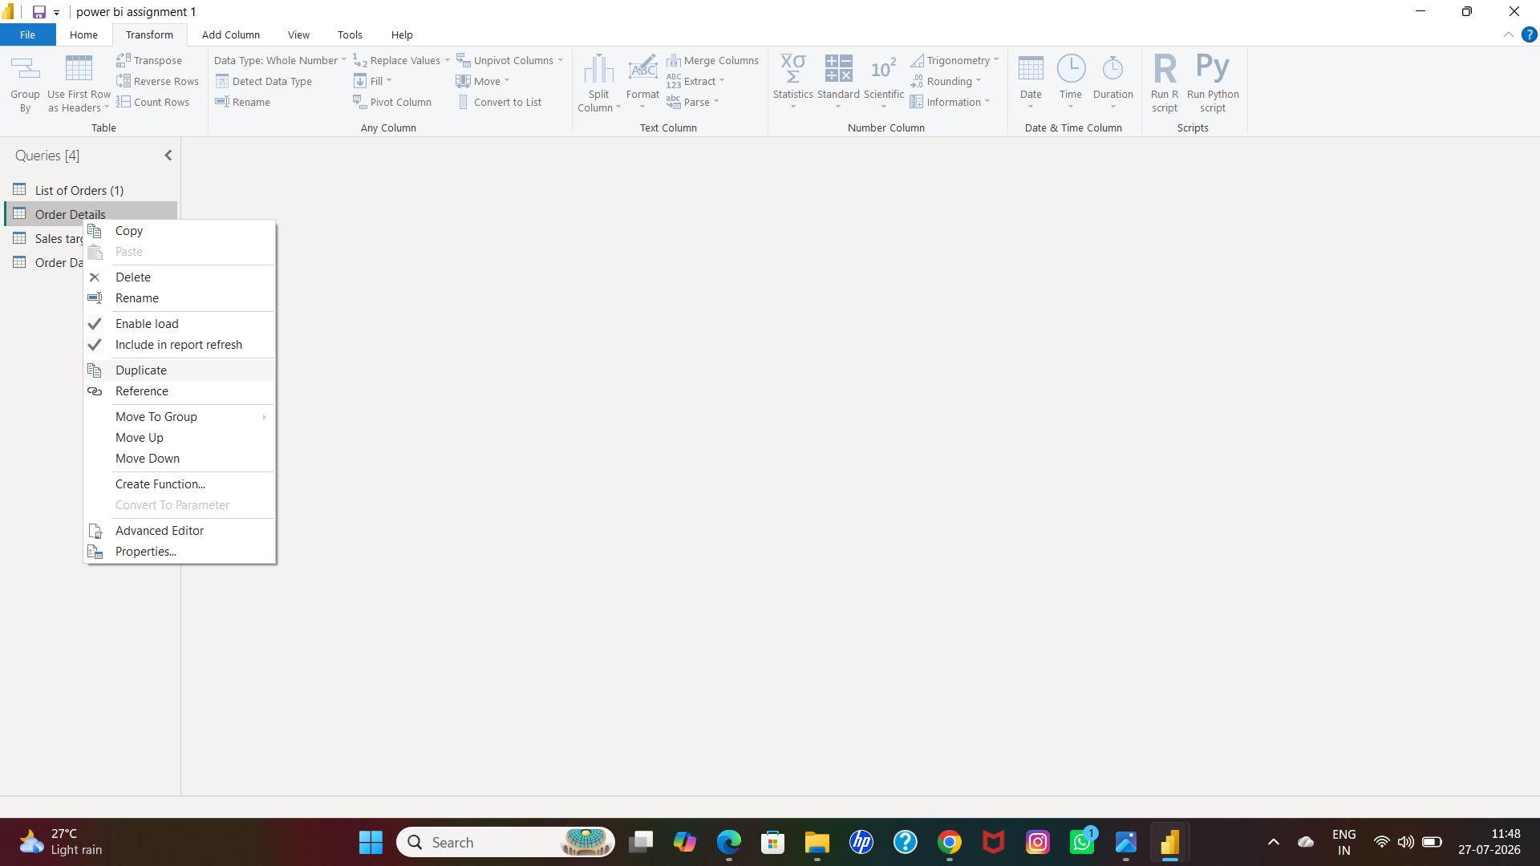

SCREENSHOT-37

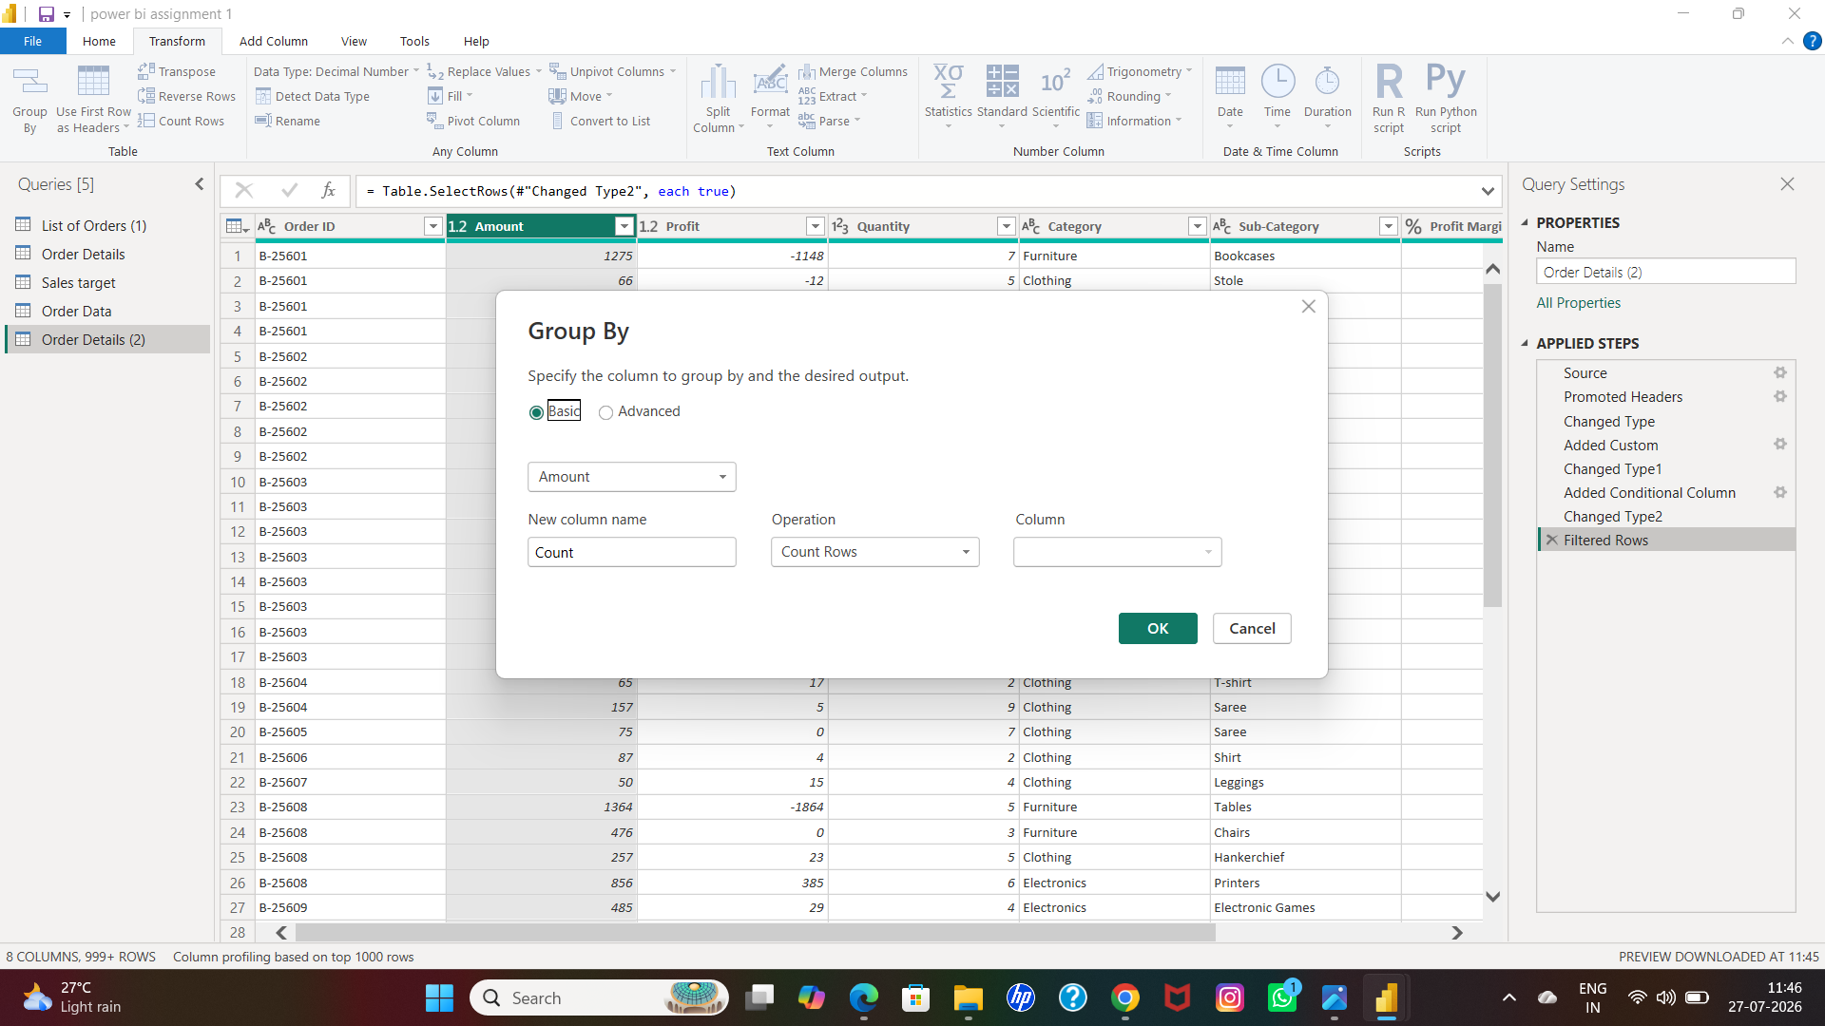

SCREENSHOT-38

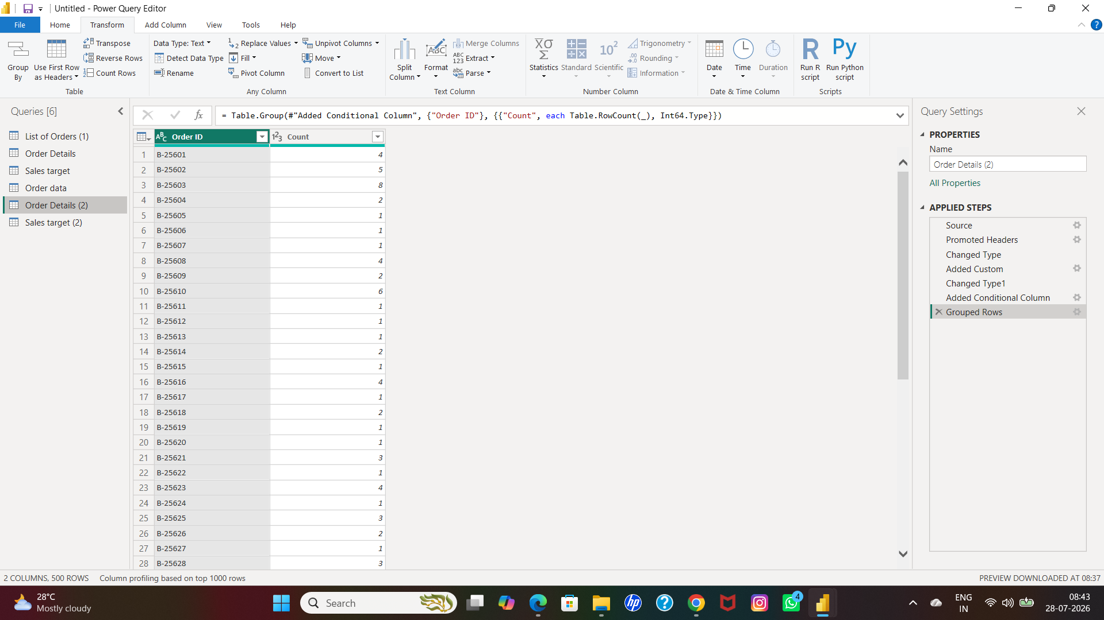

SOLUTION

- Queries-order details-right click-select duplicate

- And then go to transform-group by-fill up the each box as per query

Q18:● Duplicate the “Sales Target” table and aggregate the total target amount by Month of Order Date.

SCREENSHOT-39

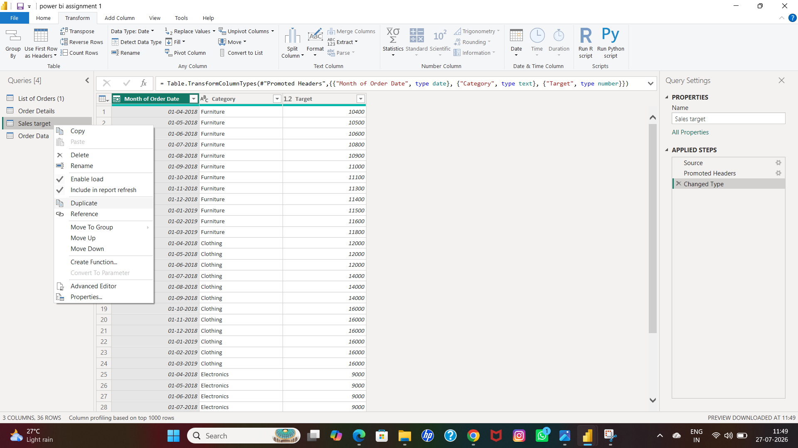

SCREENSHOT-40

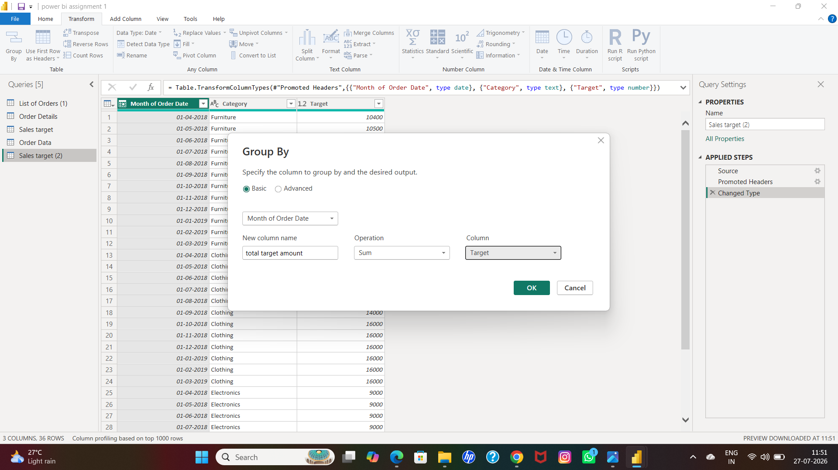

SCREENSHOT-41

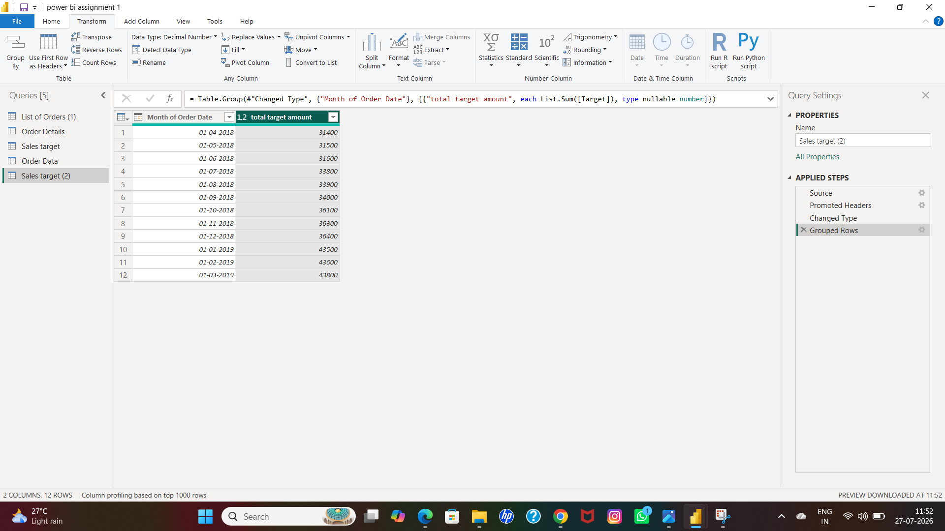

SOLUTION

- Queries-order details-right click-select duplicate

- And then go to transform-group by-fill up the each box as per query

Q19:● Establish a relationship between the “List of Orders” and “Order Details” tables using the ‘Order ID’ column.

SCREENSHOT-42

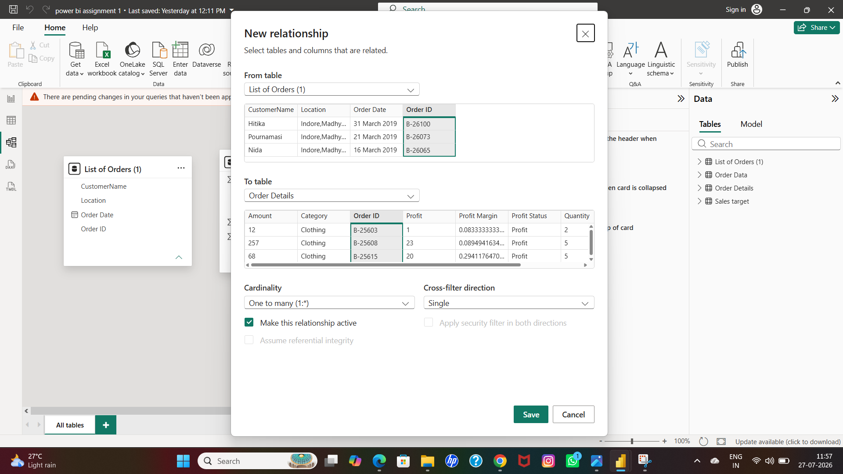

SCREENSHOT-43

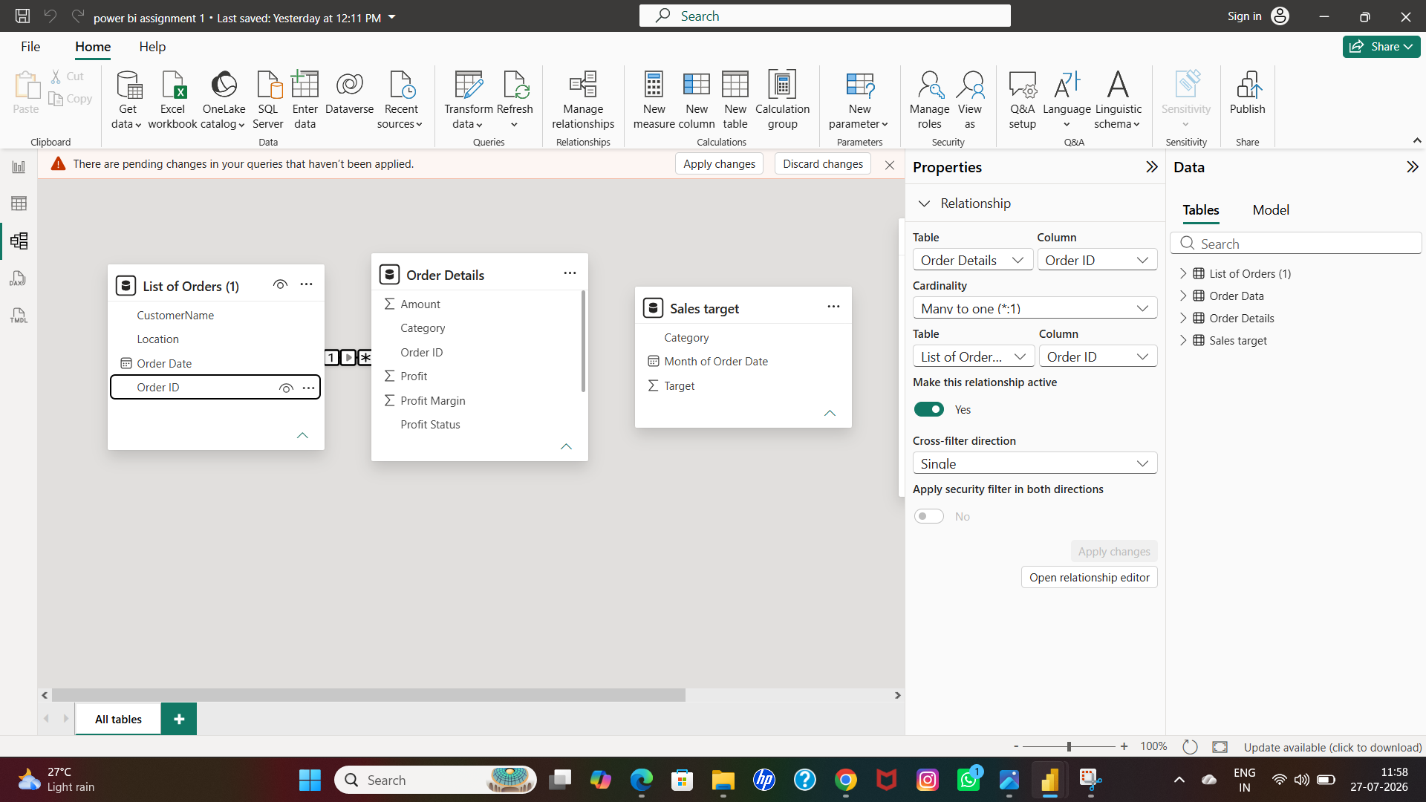

SOLUTION

- Go to power bi desk-click left side of the screen-click model view

- I had to delete previous relationships between the all tables first by right click between the lines

- And then pull the list of orders order id to order details order id bosby click and pull either of any box

- And then box open and click ok

Q20:● Build a relationship between the “Order Details” and “Sales Target” tables based on the ‘Category’ column. Click "Manage relationships" and ensure this relationship is active

SCREENSHOT-44

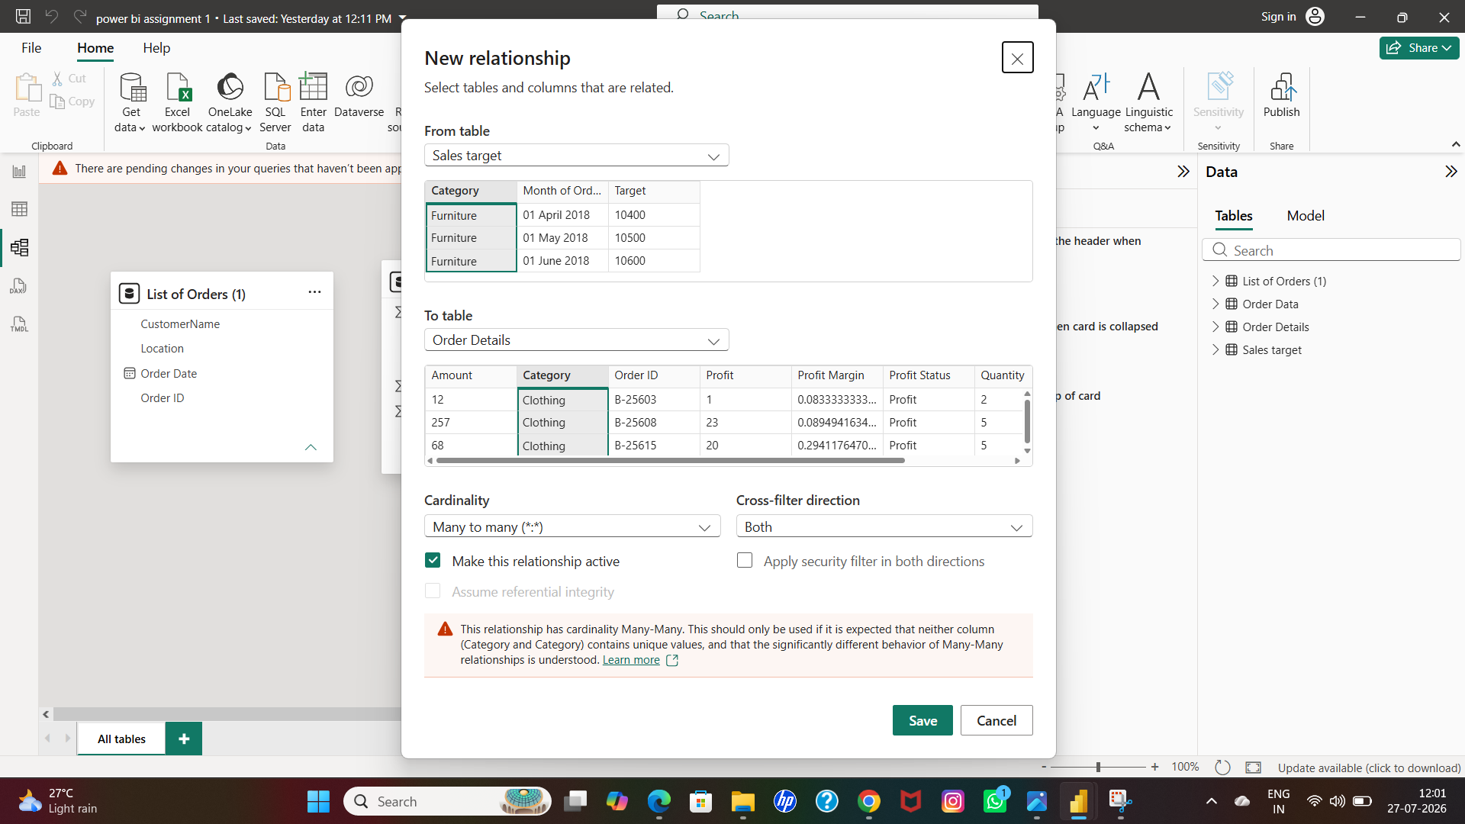

SCREENSHOT-45

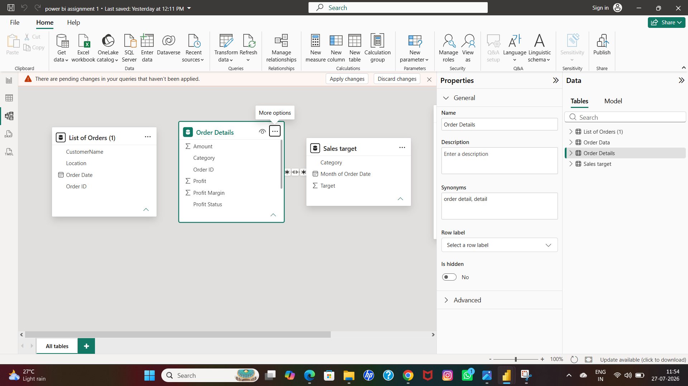

SCREENSHOT-46

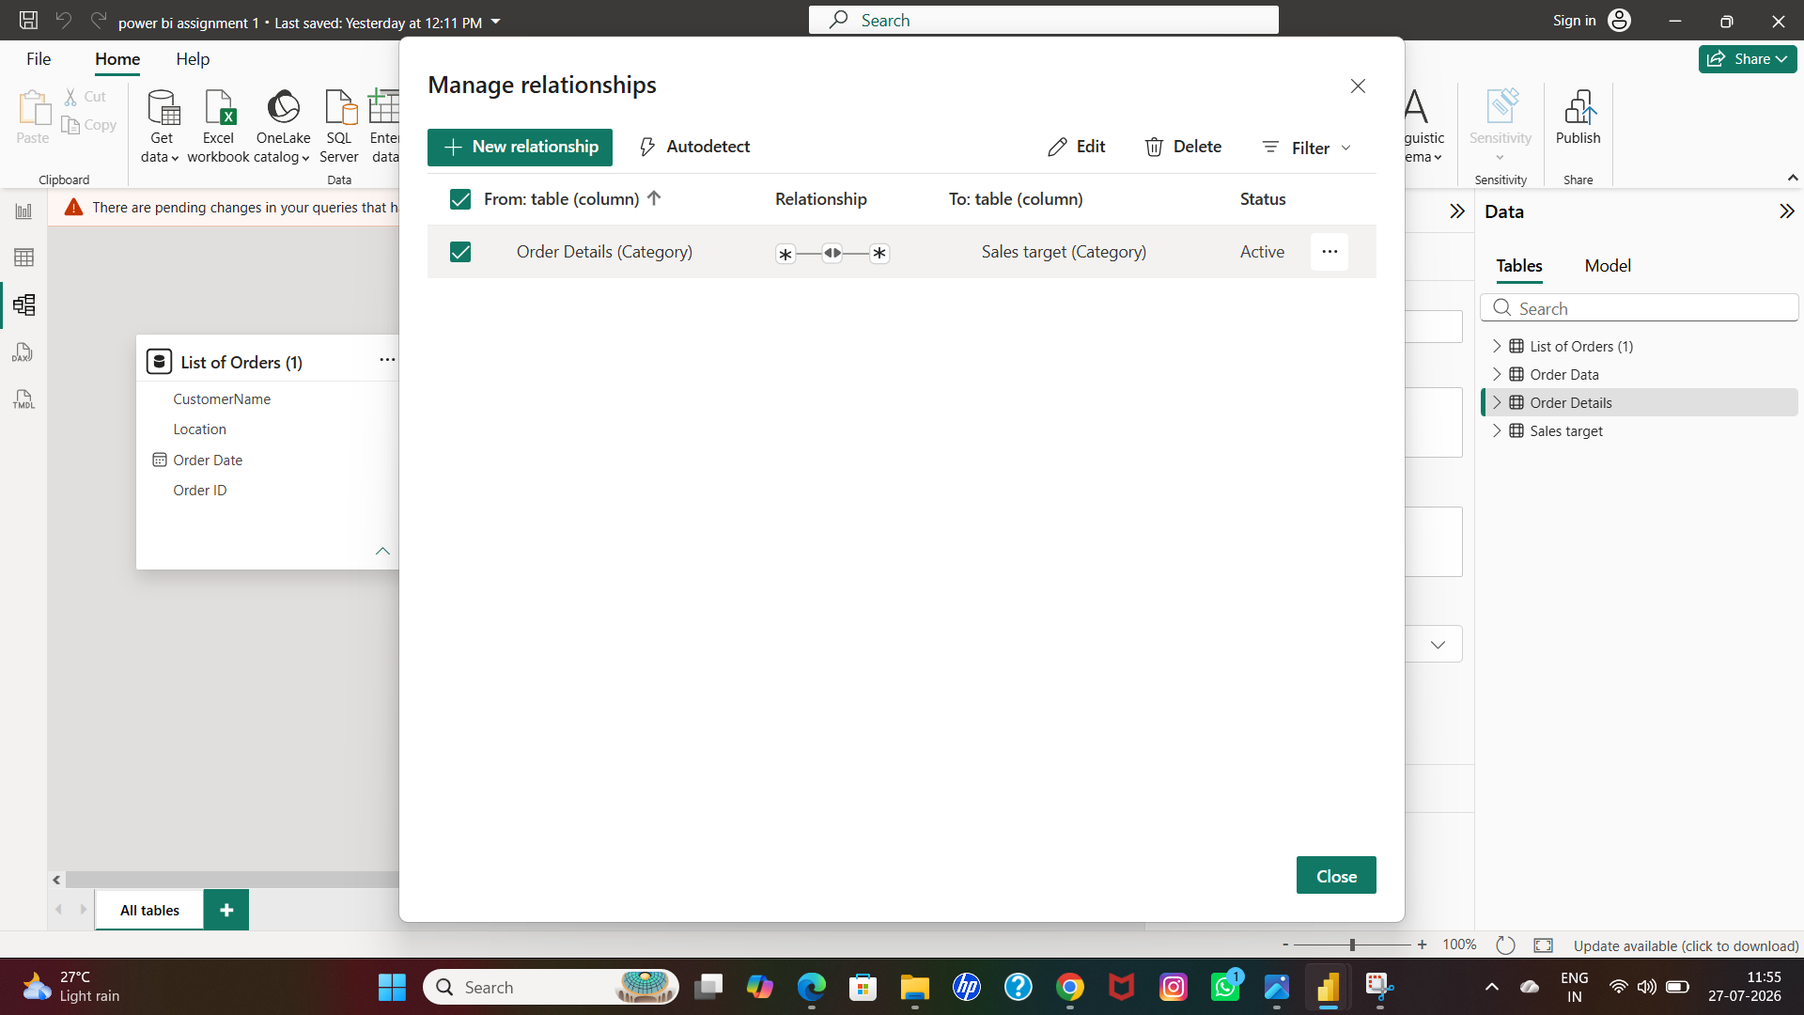

SOLUTION

- Go to power bi desk-click left side of the screen-click model view

- I had to delete previous relationships between the all tables first by right click between the lines

- And then pull the order details category option to sales target category option by click and pull either of any box

- And then box open and click ok
- Then make sure manage relationship is active on the box

- Or go to home-manage relationship-active

